Every user must log in to be able to use the functionality of PRS

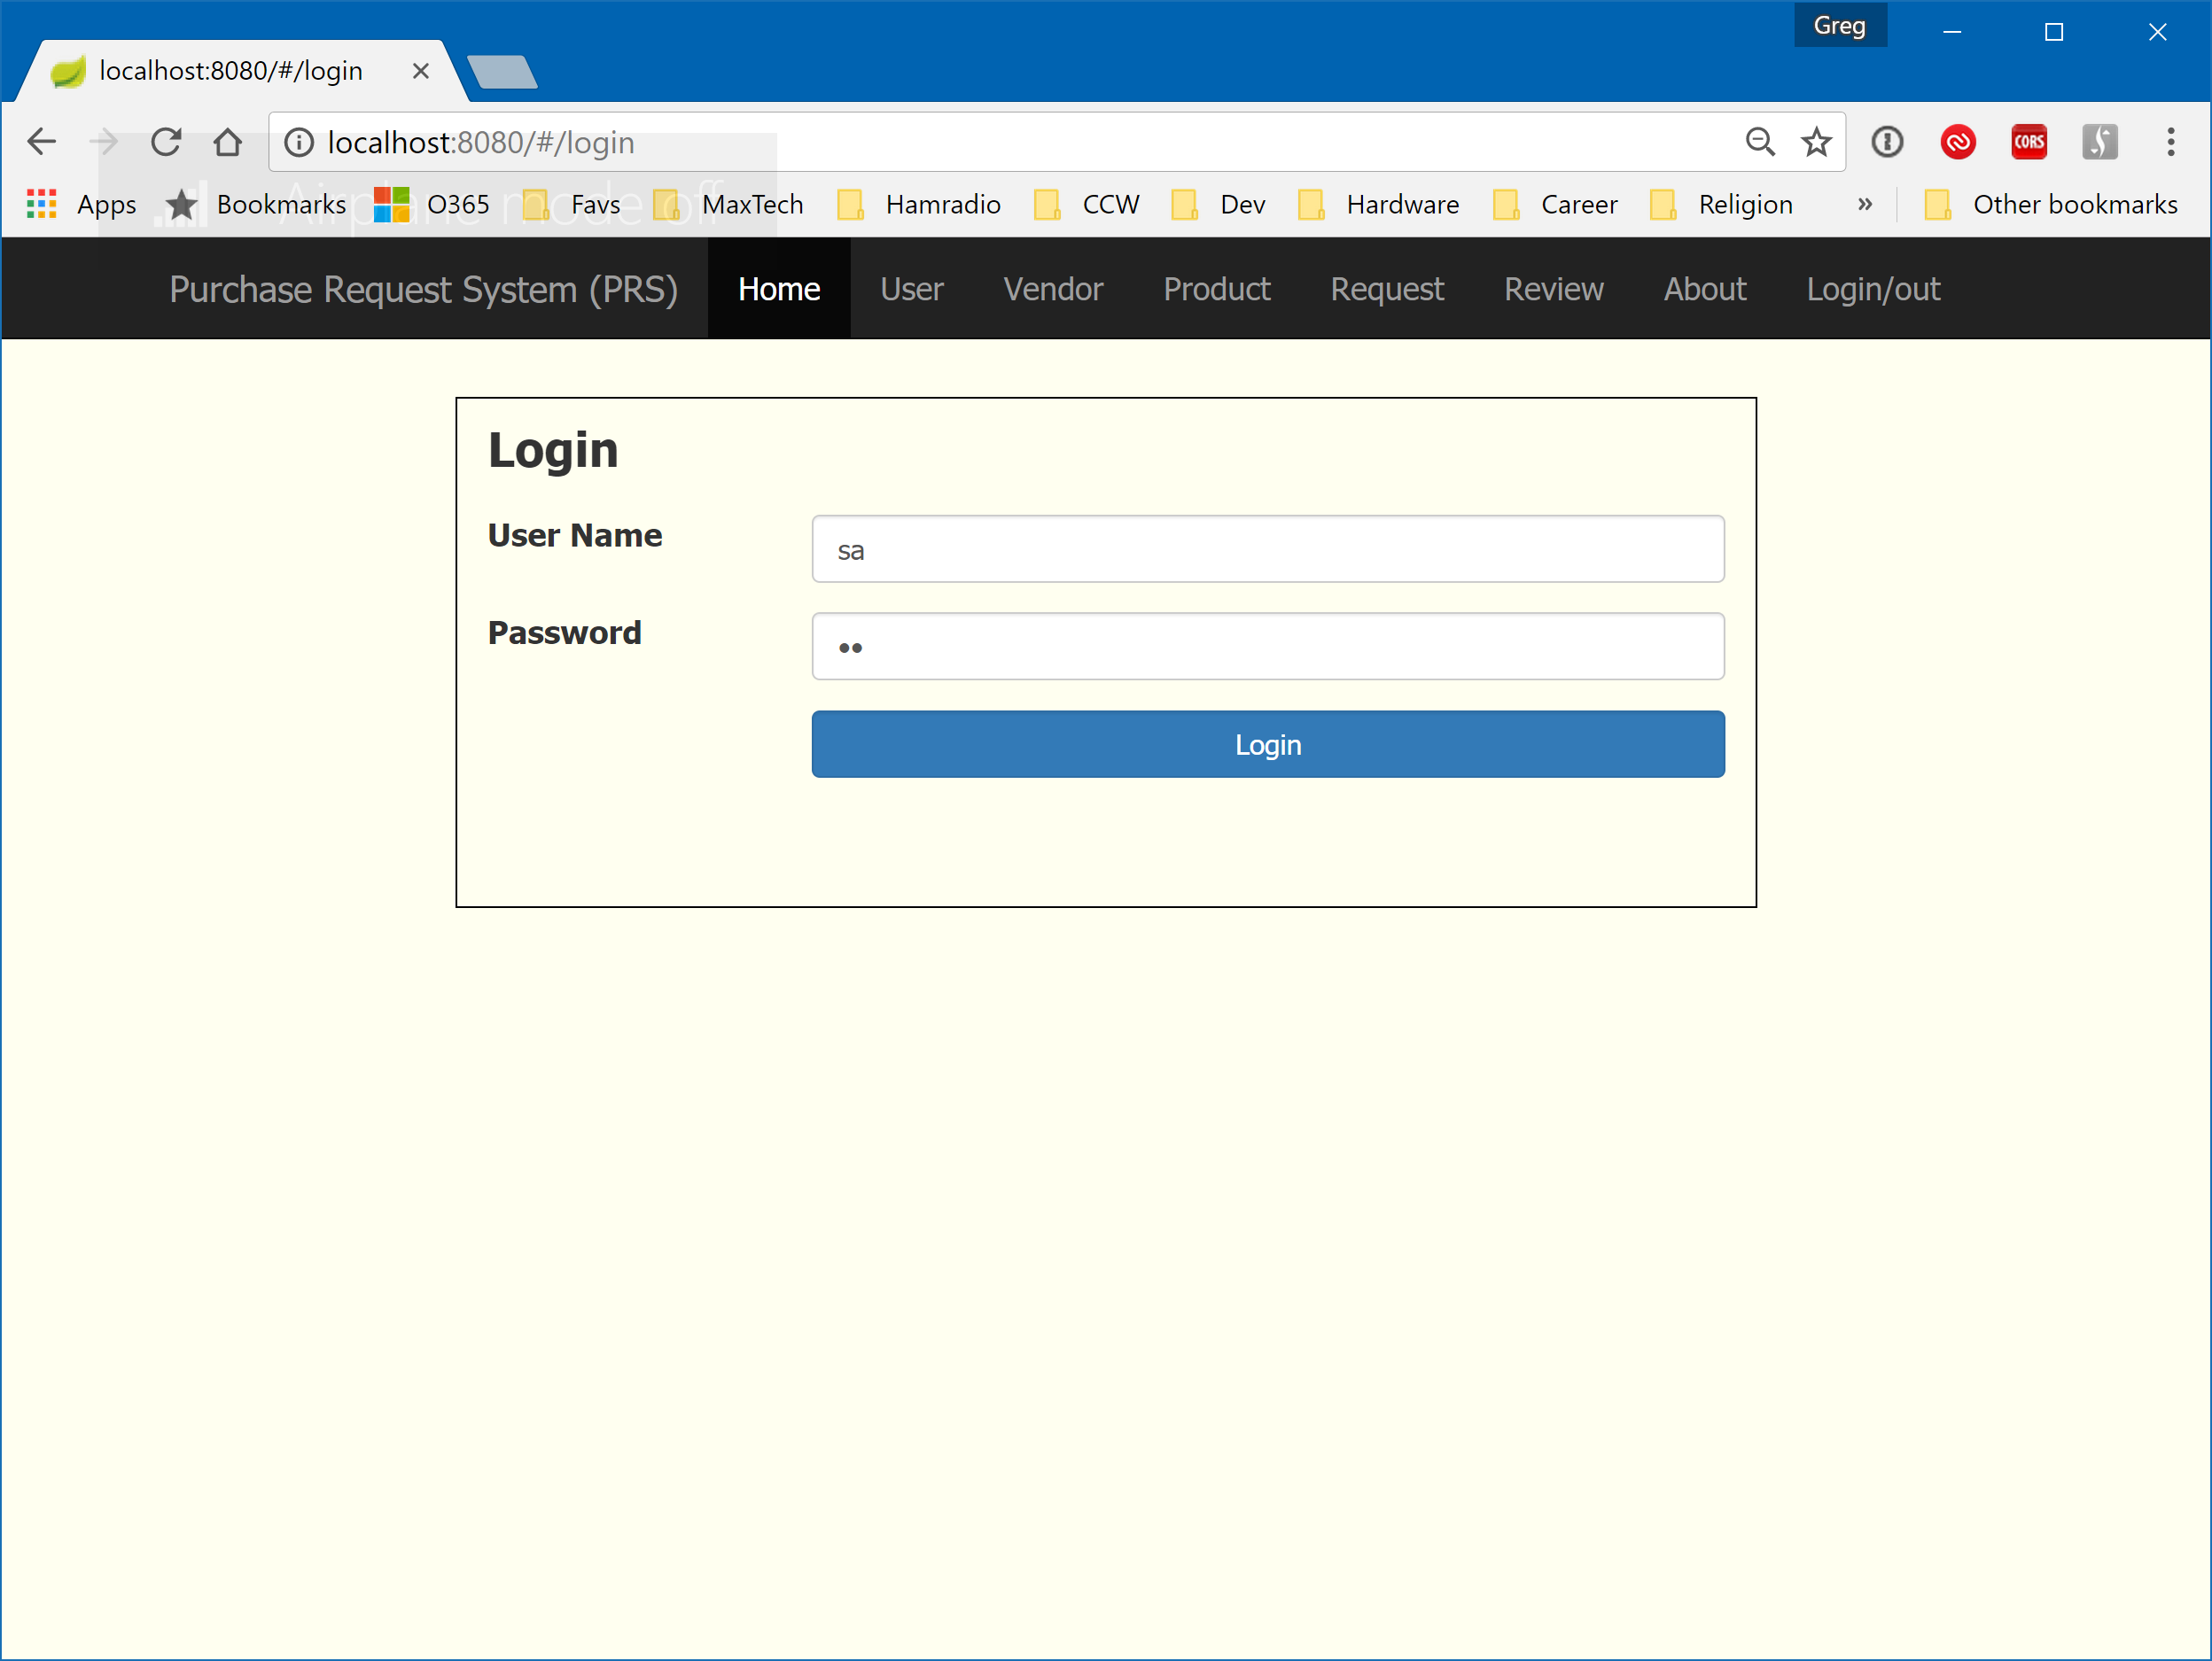

Figure - Login

The Home page is incomplete at this time.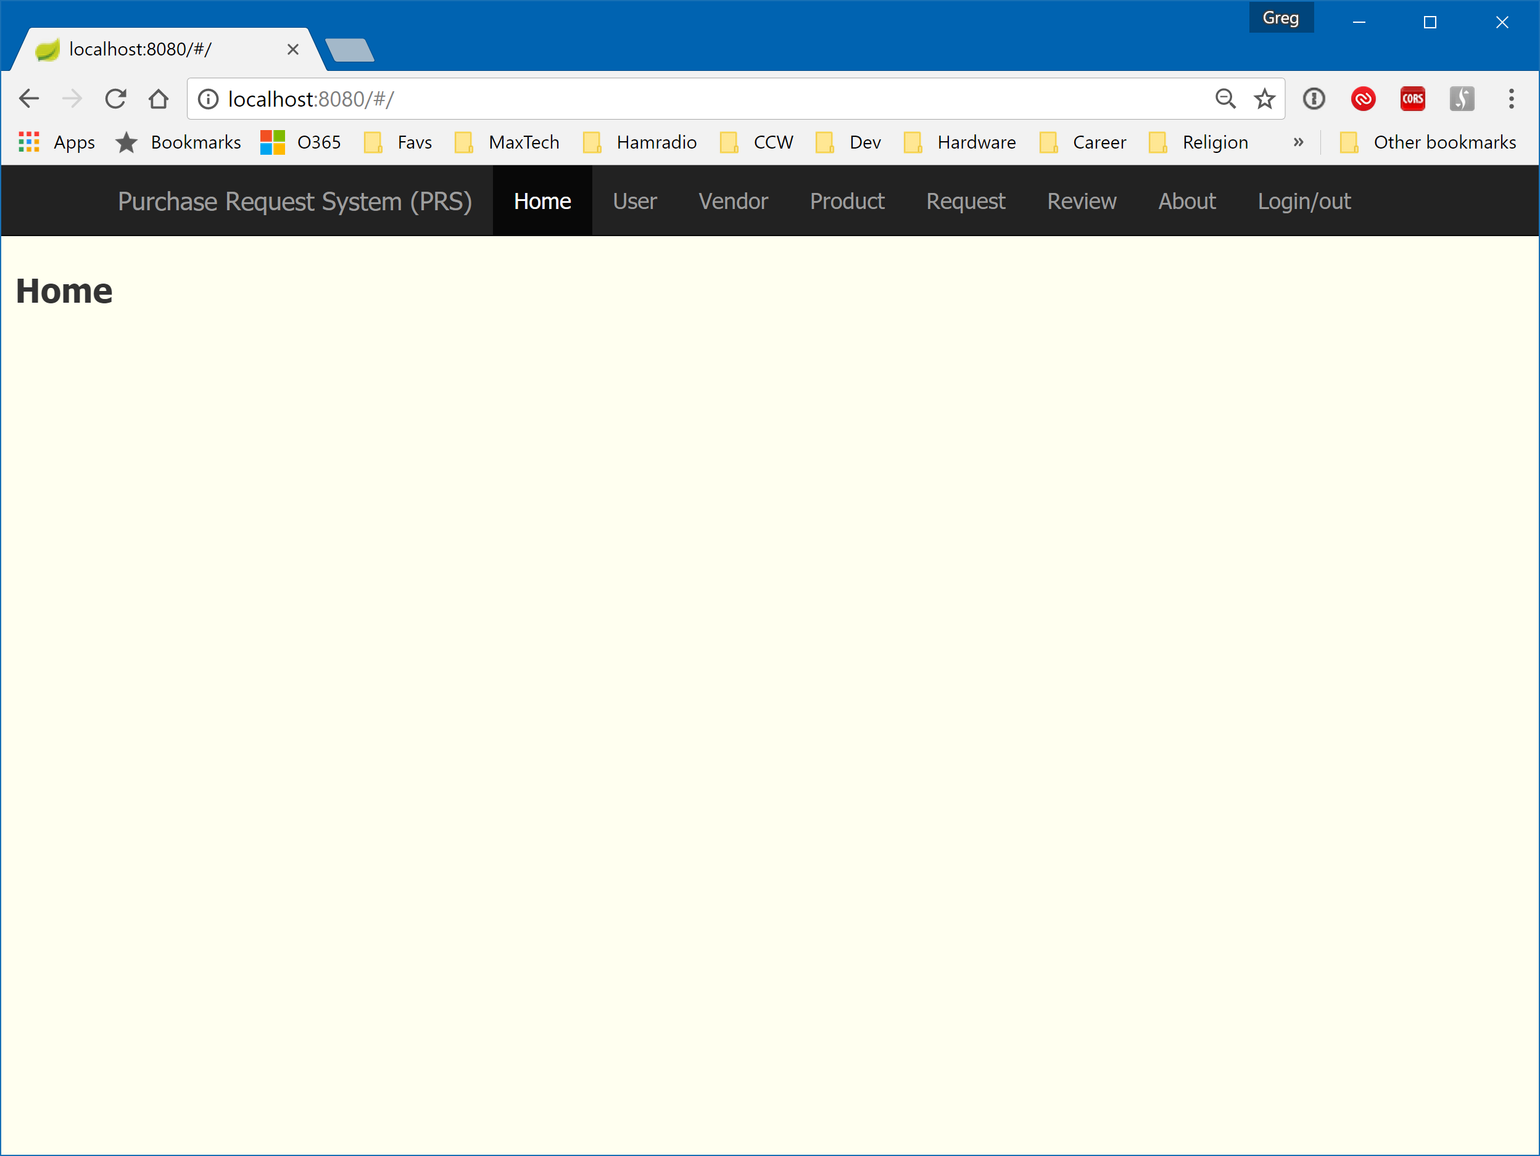

Figure - Home page (incomplete)

Only those users marked IsAdmin may maintain the User, Vendor and Product data. This is a user list view for an admin.

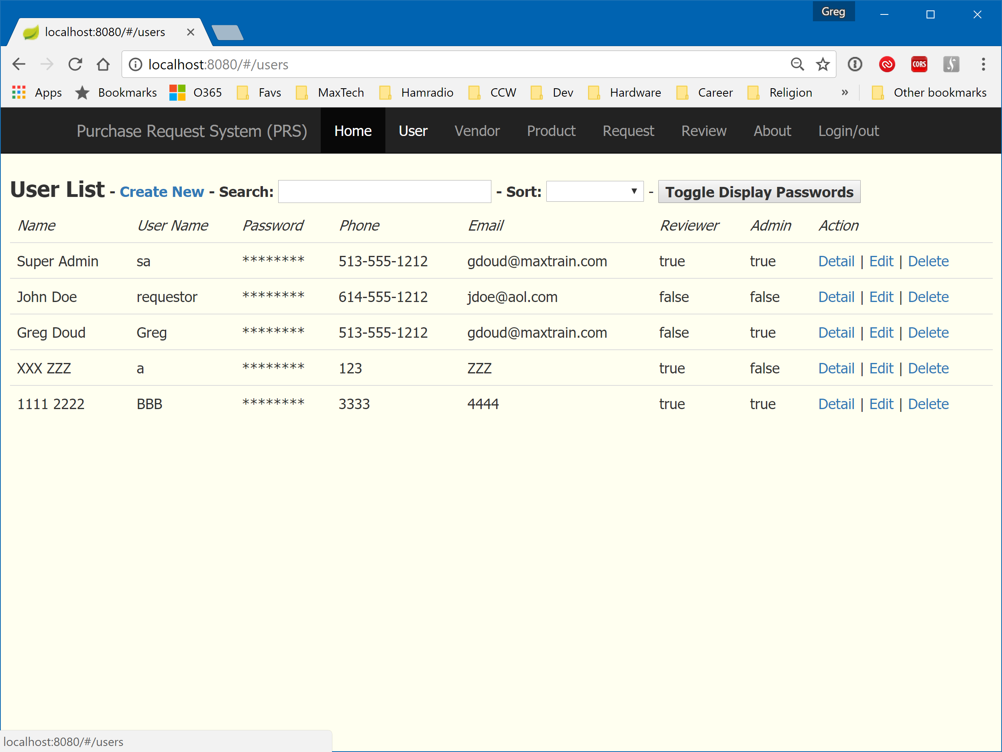

Figure - User List Page (Admin view)

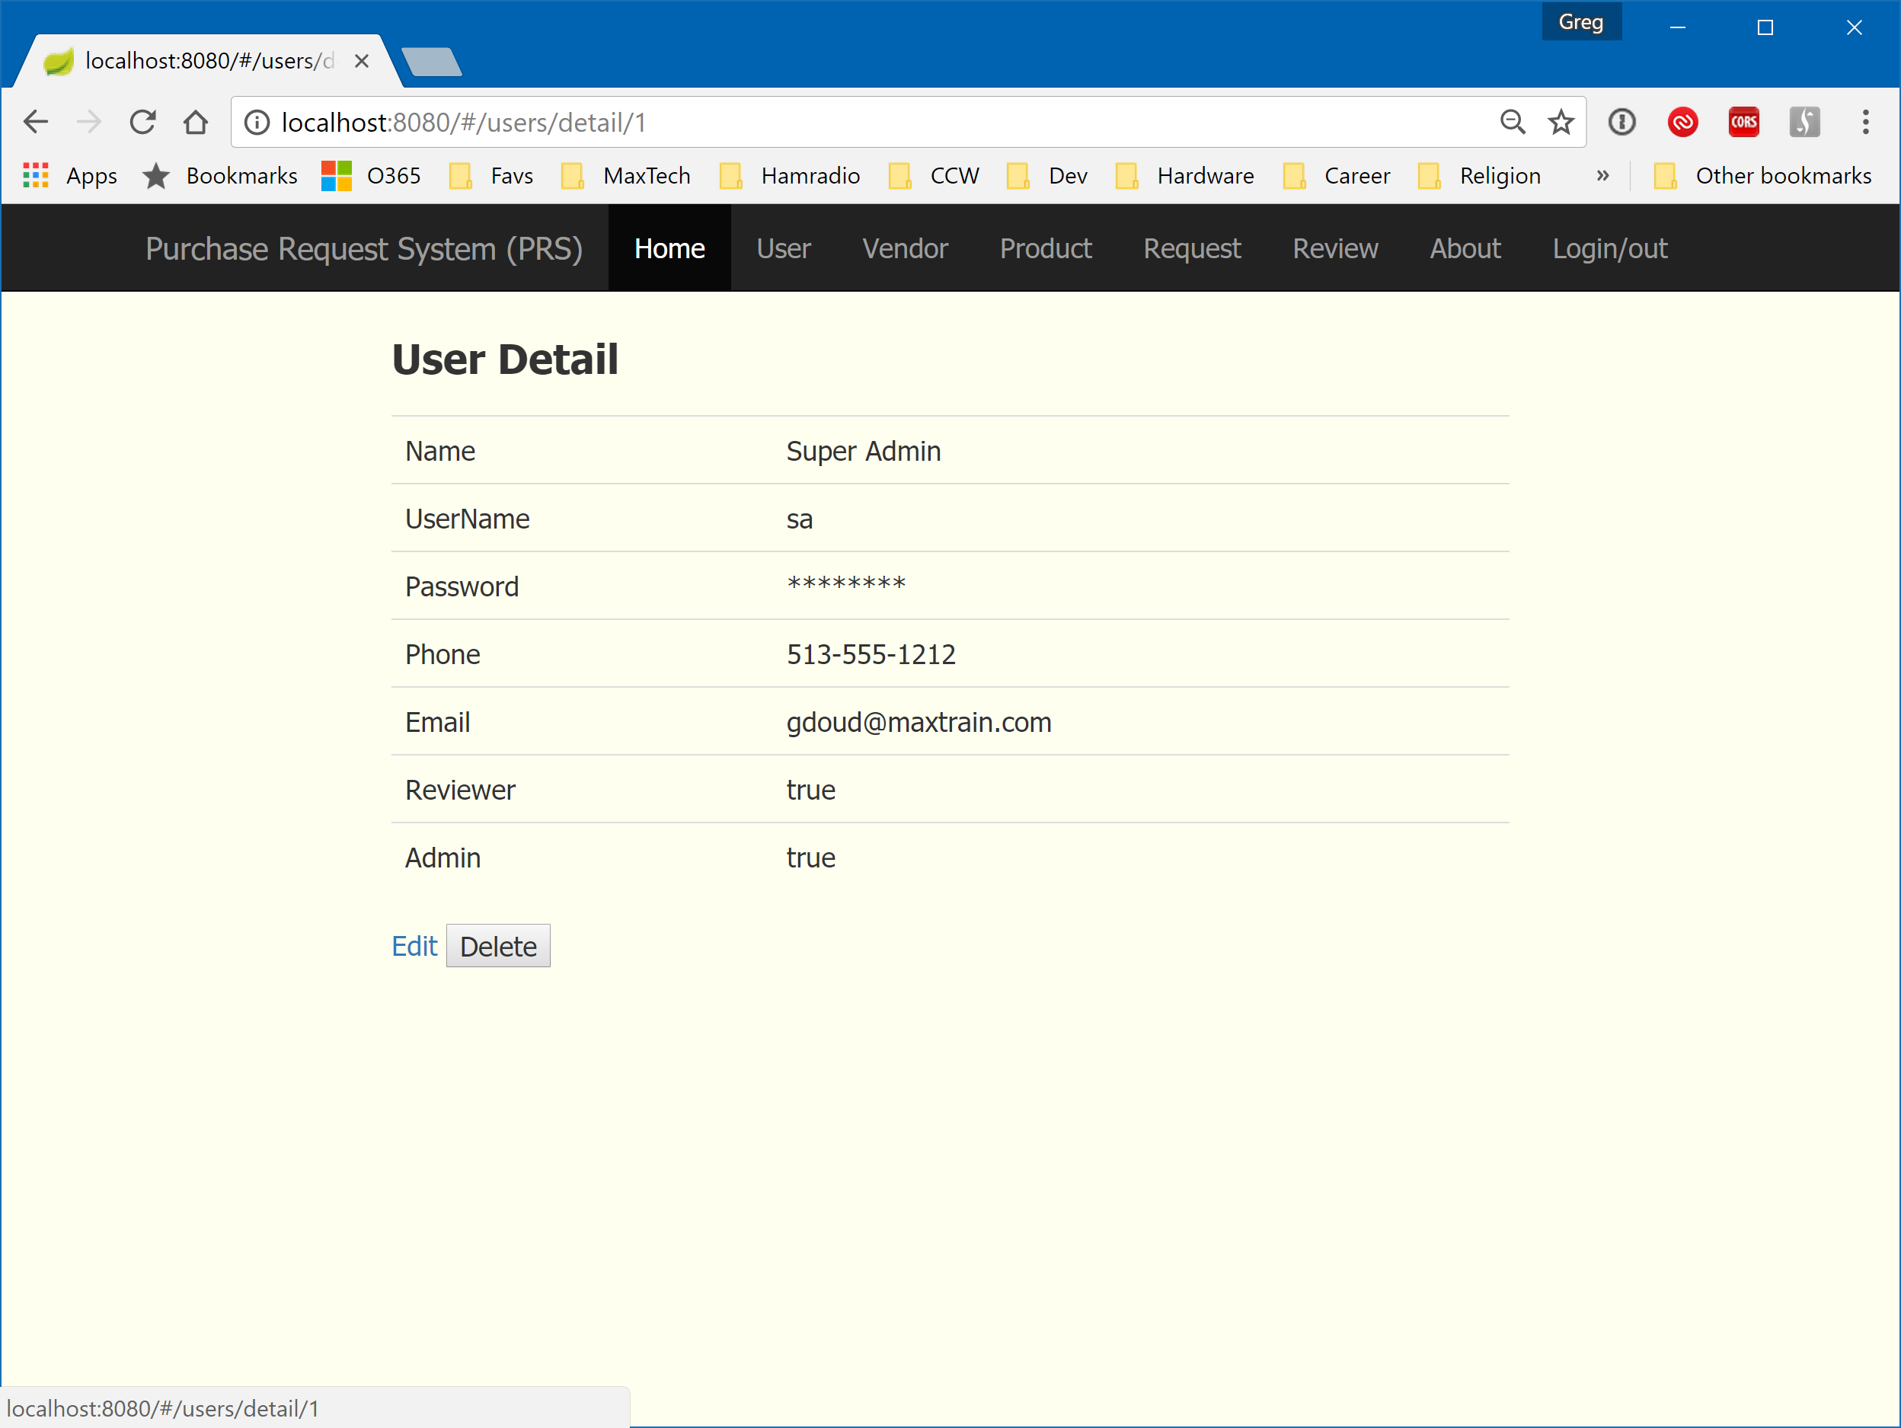

Figure - User Detail (Admin View)

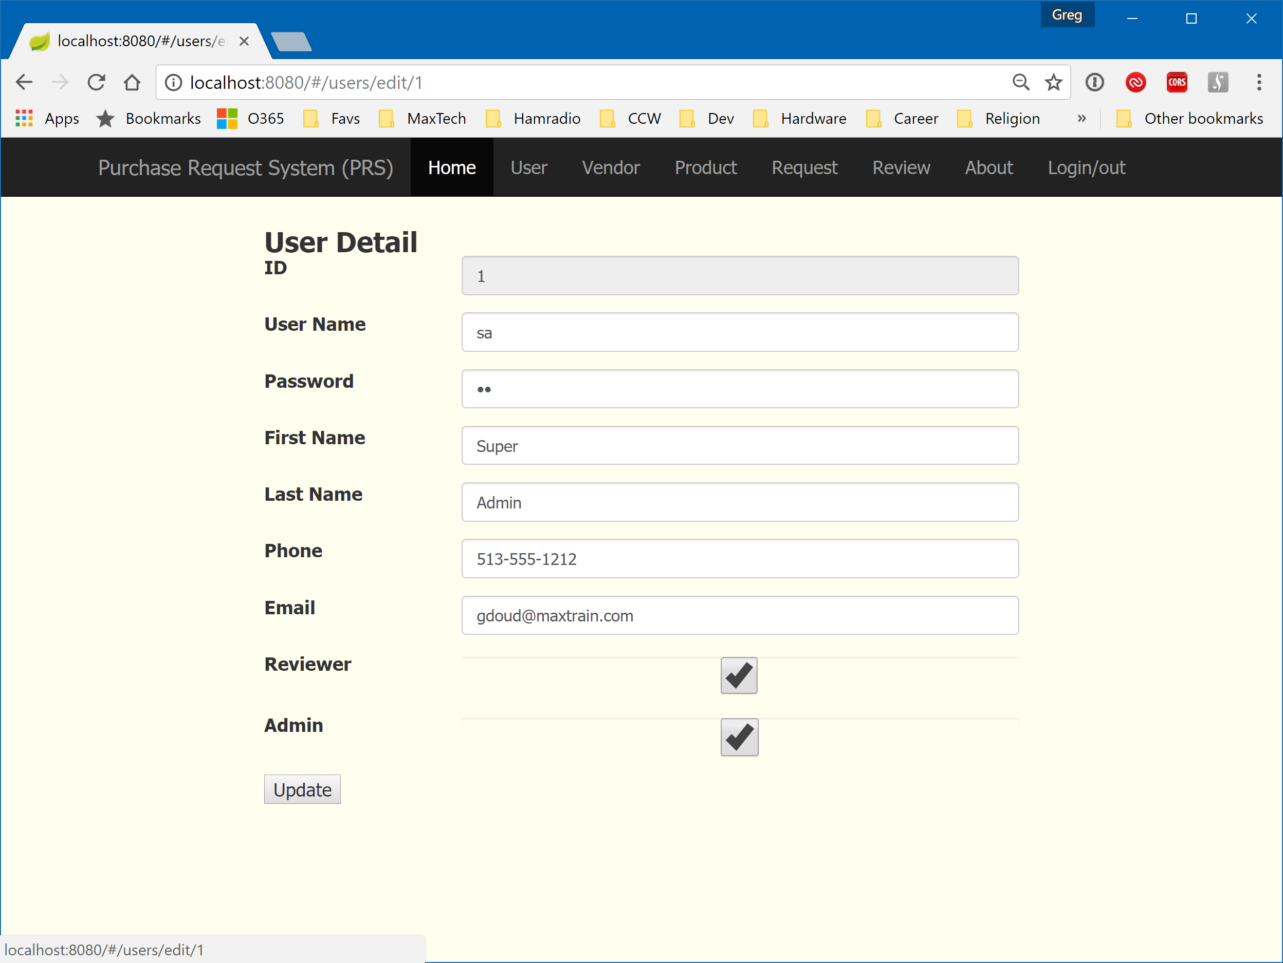

Figure - User Edit (Admin View)

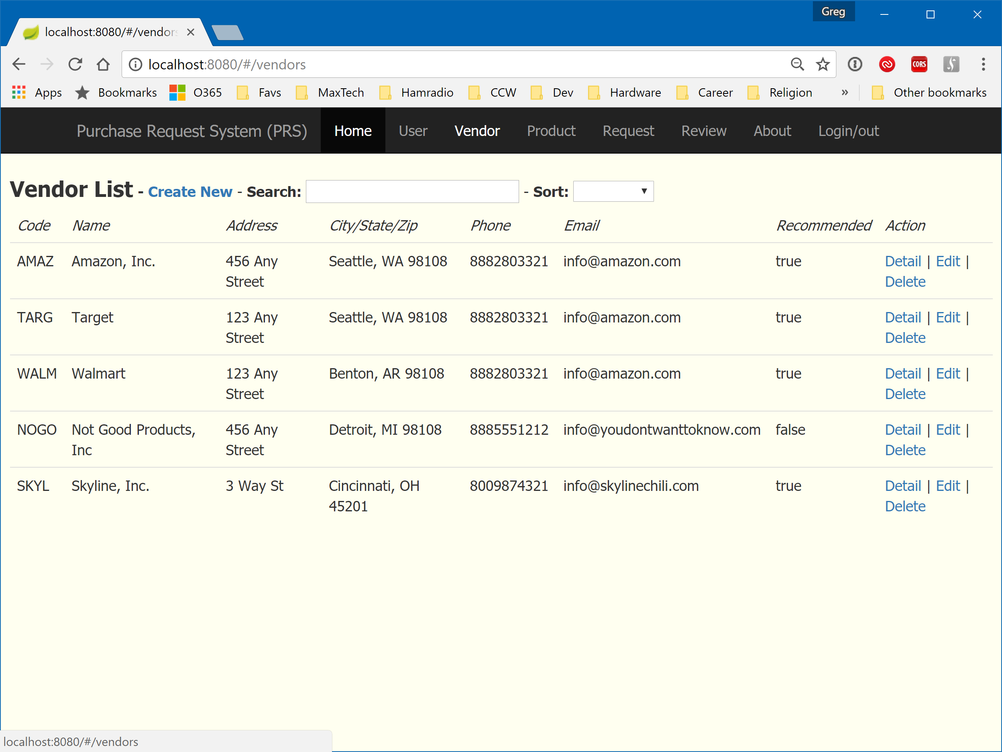

Figure - Vendor List (Admin View)

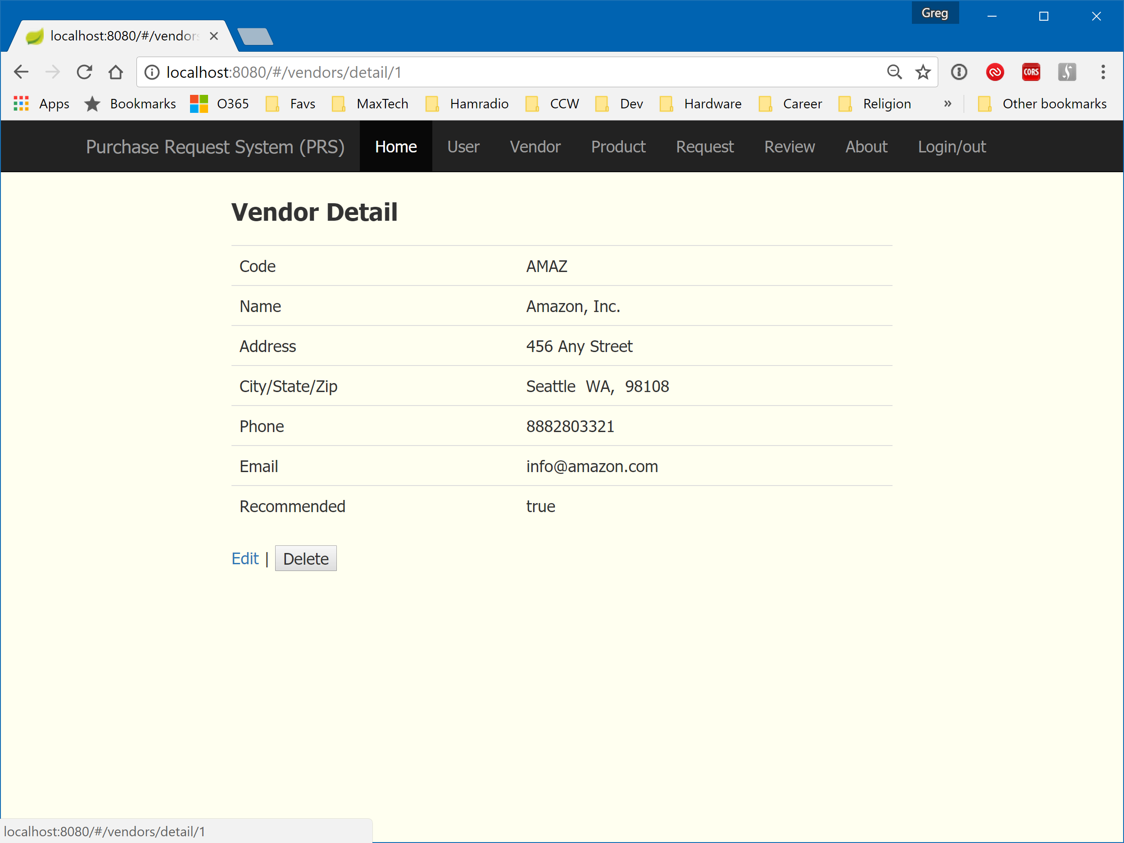

Figure - Vendor Detail (Admin View)

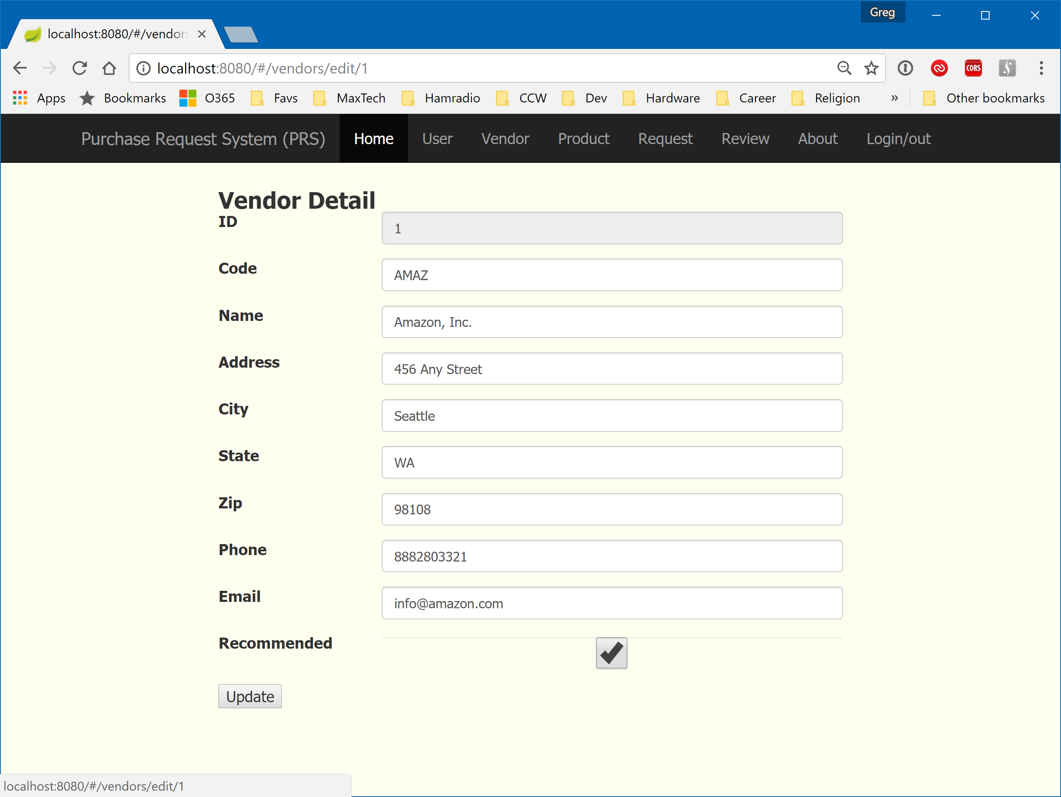

Figure - Vendor Edit (Admin View)

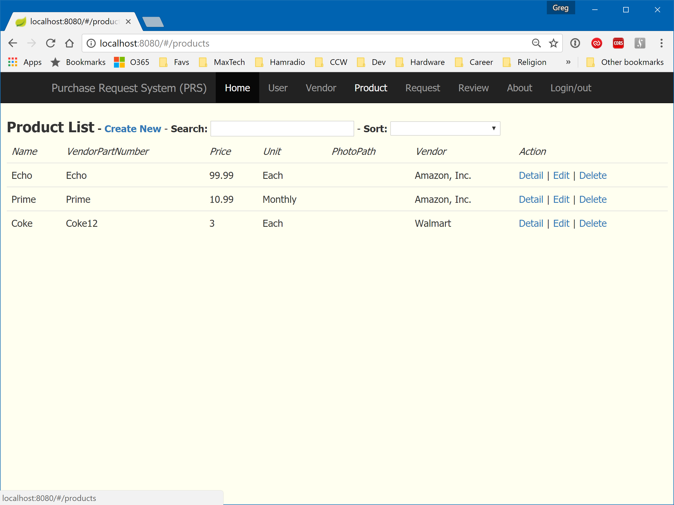

Figure - Product List (Admin View)

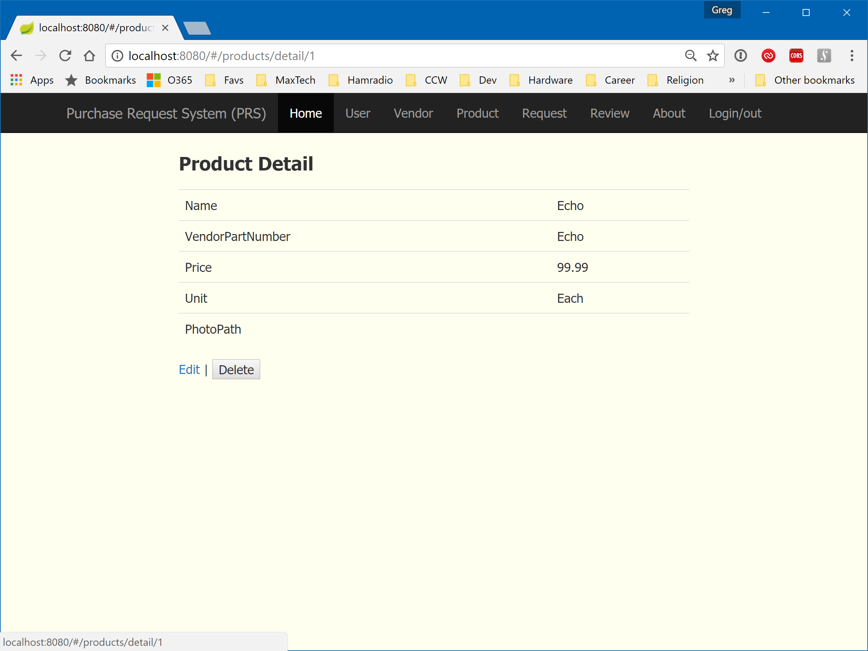

Figure - Product Detail (Admin View)

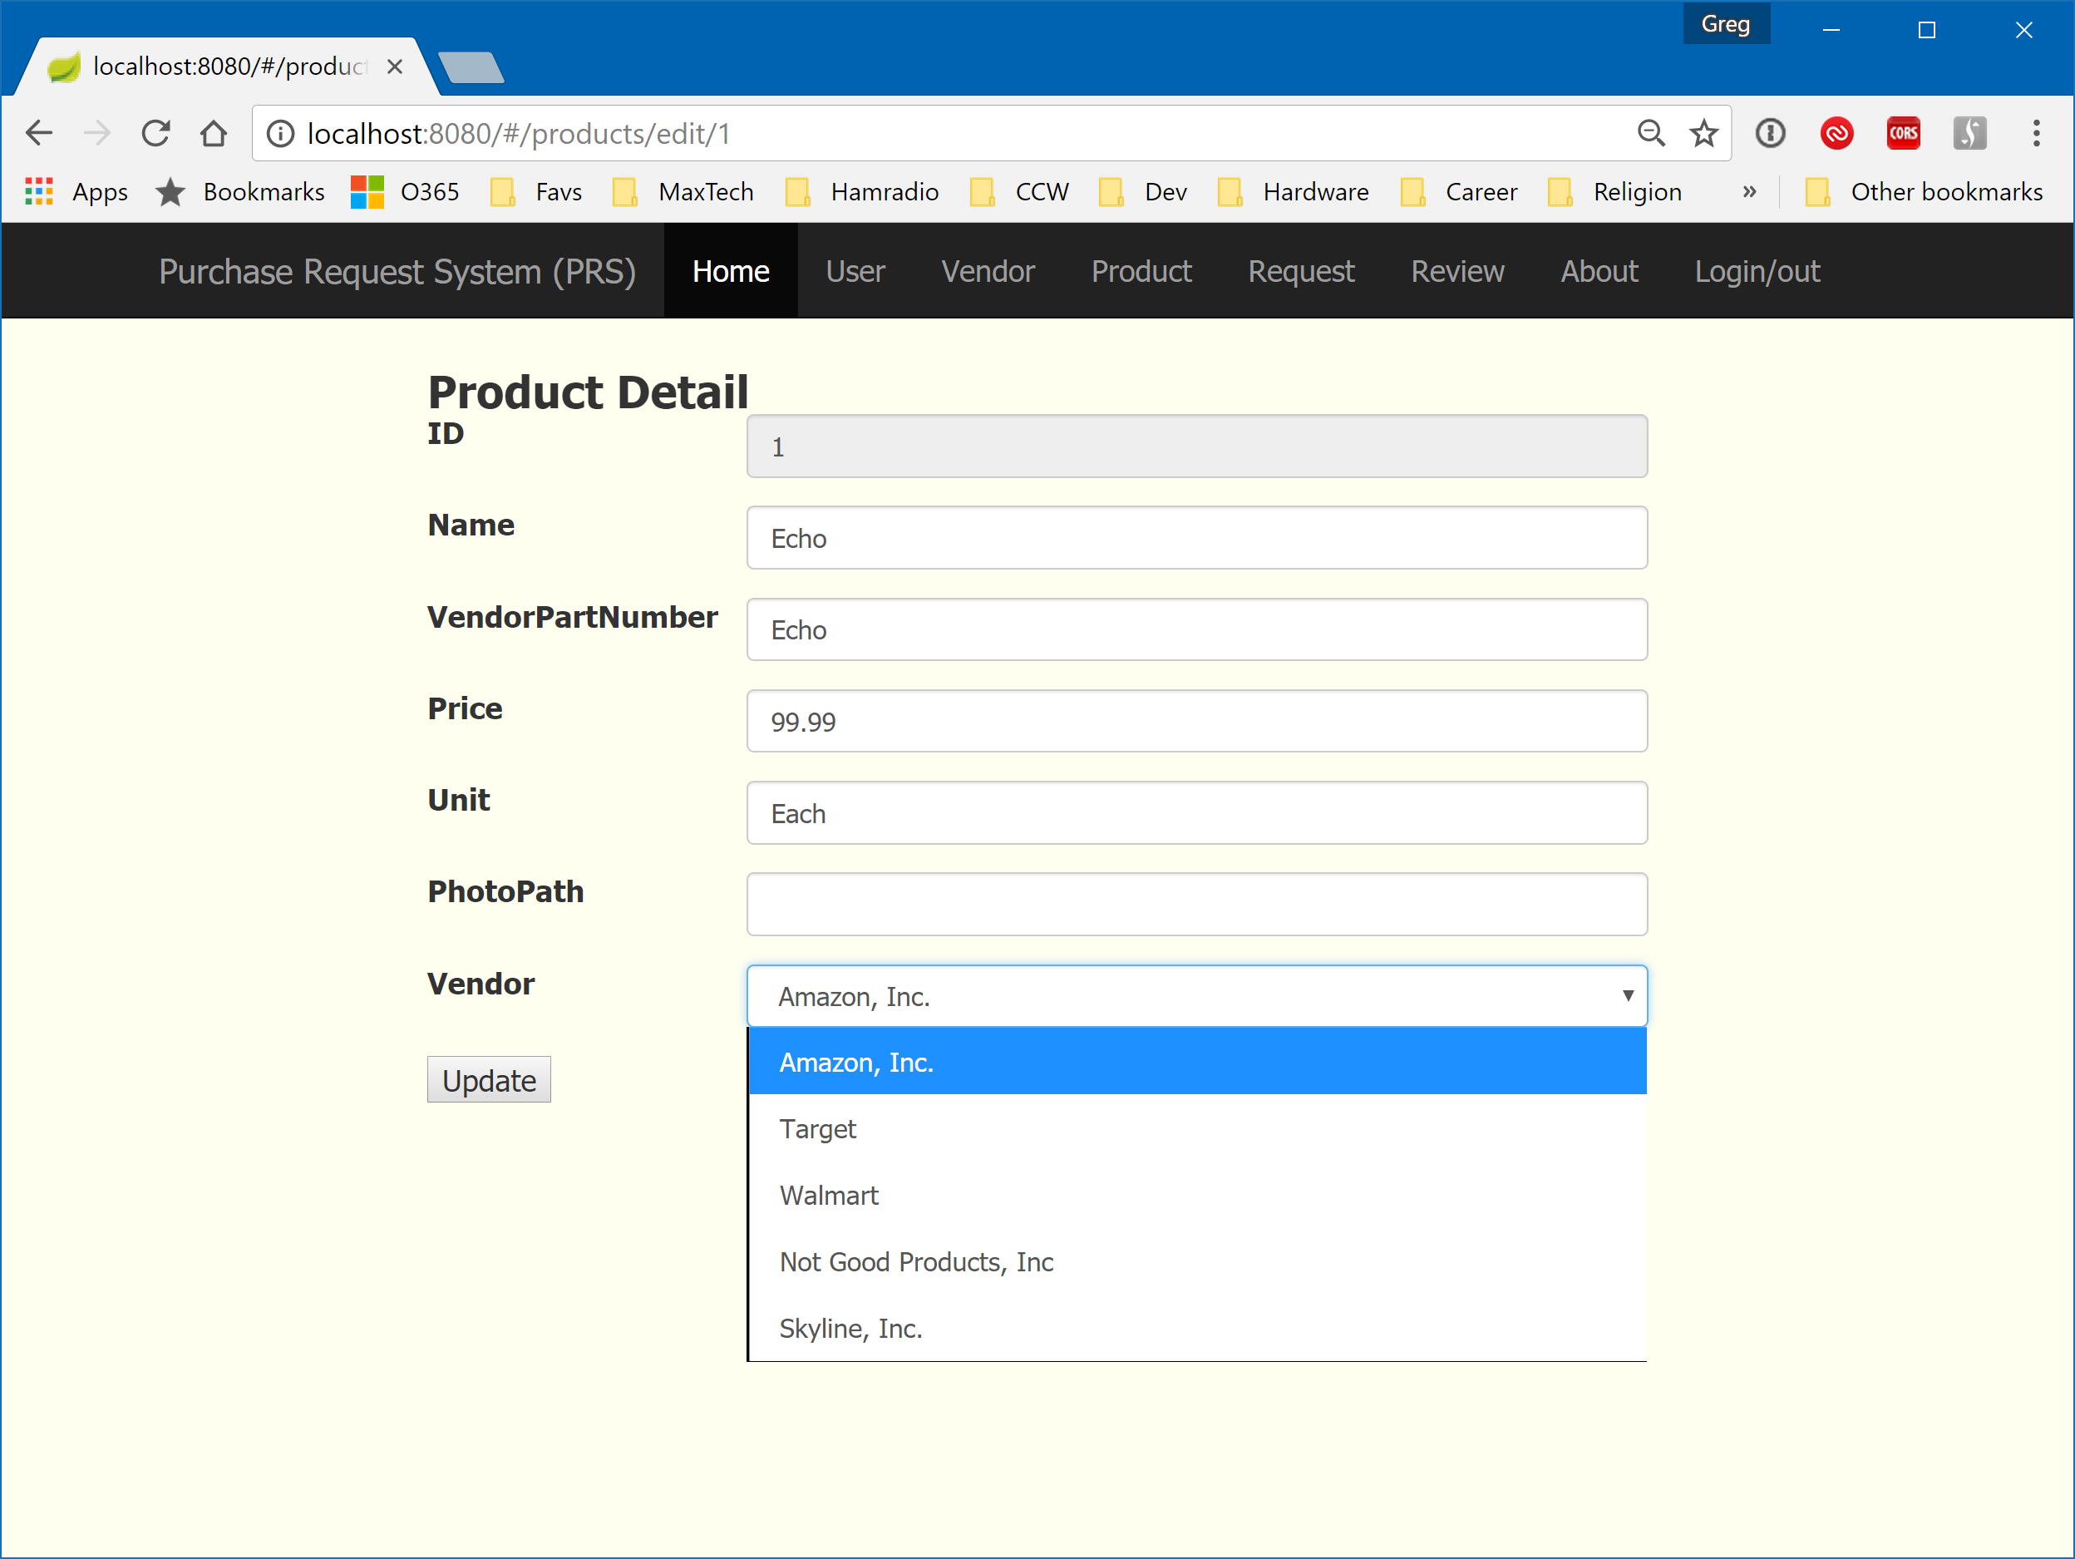

Figure - Product Edit (Admin View)

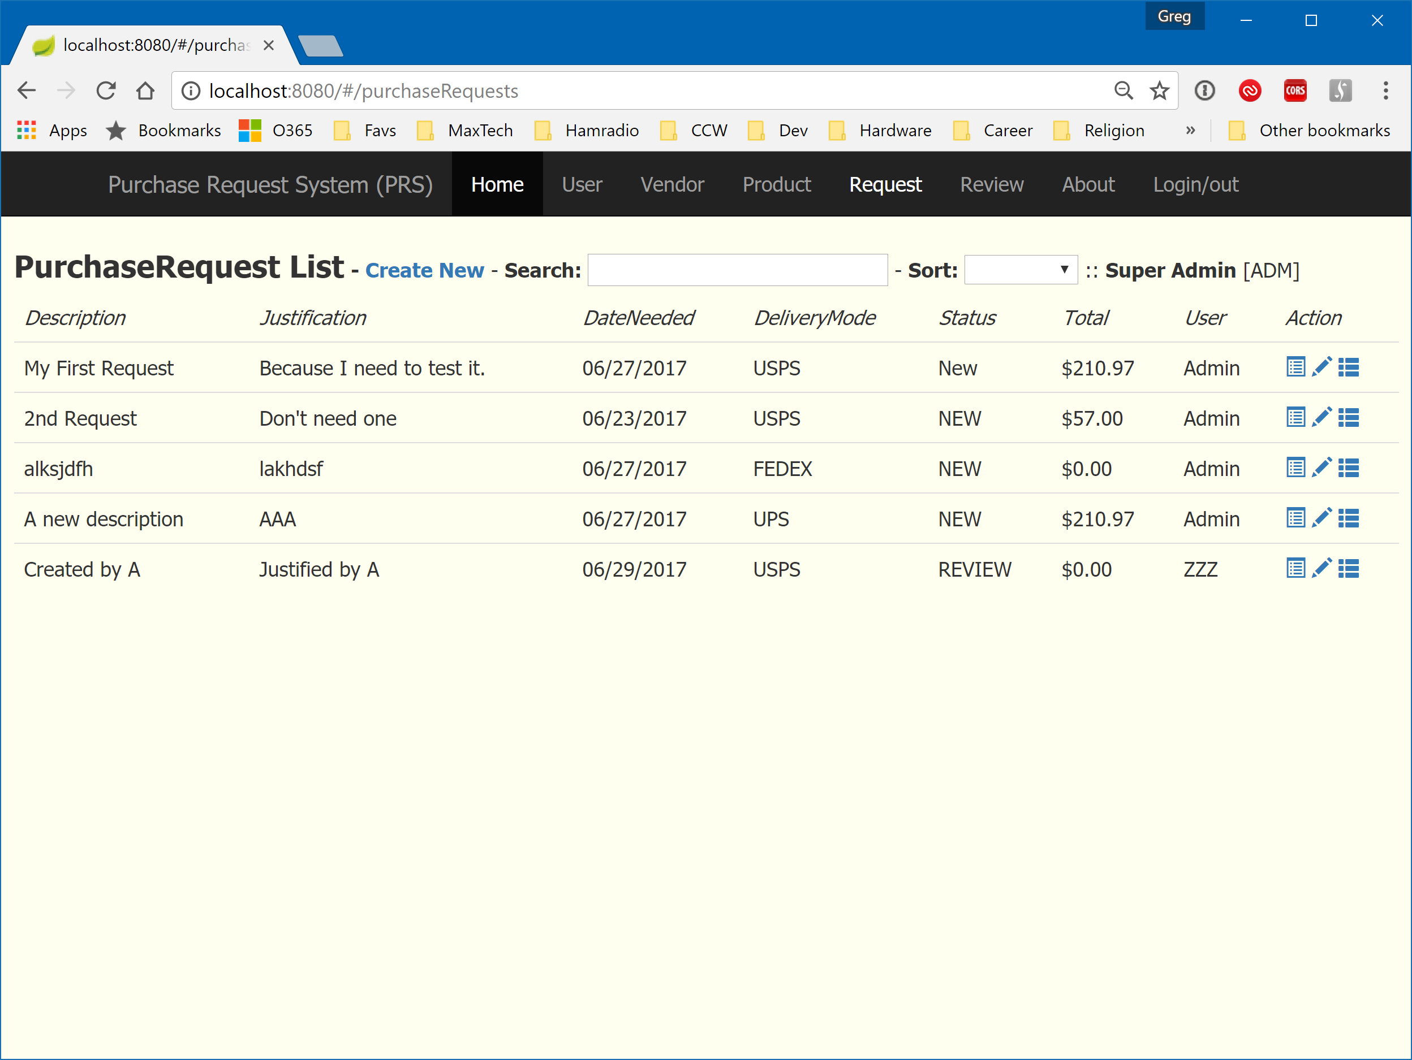

Figure - Purchase Request List (Admin View)

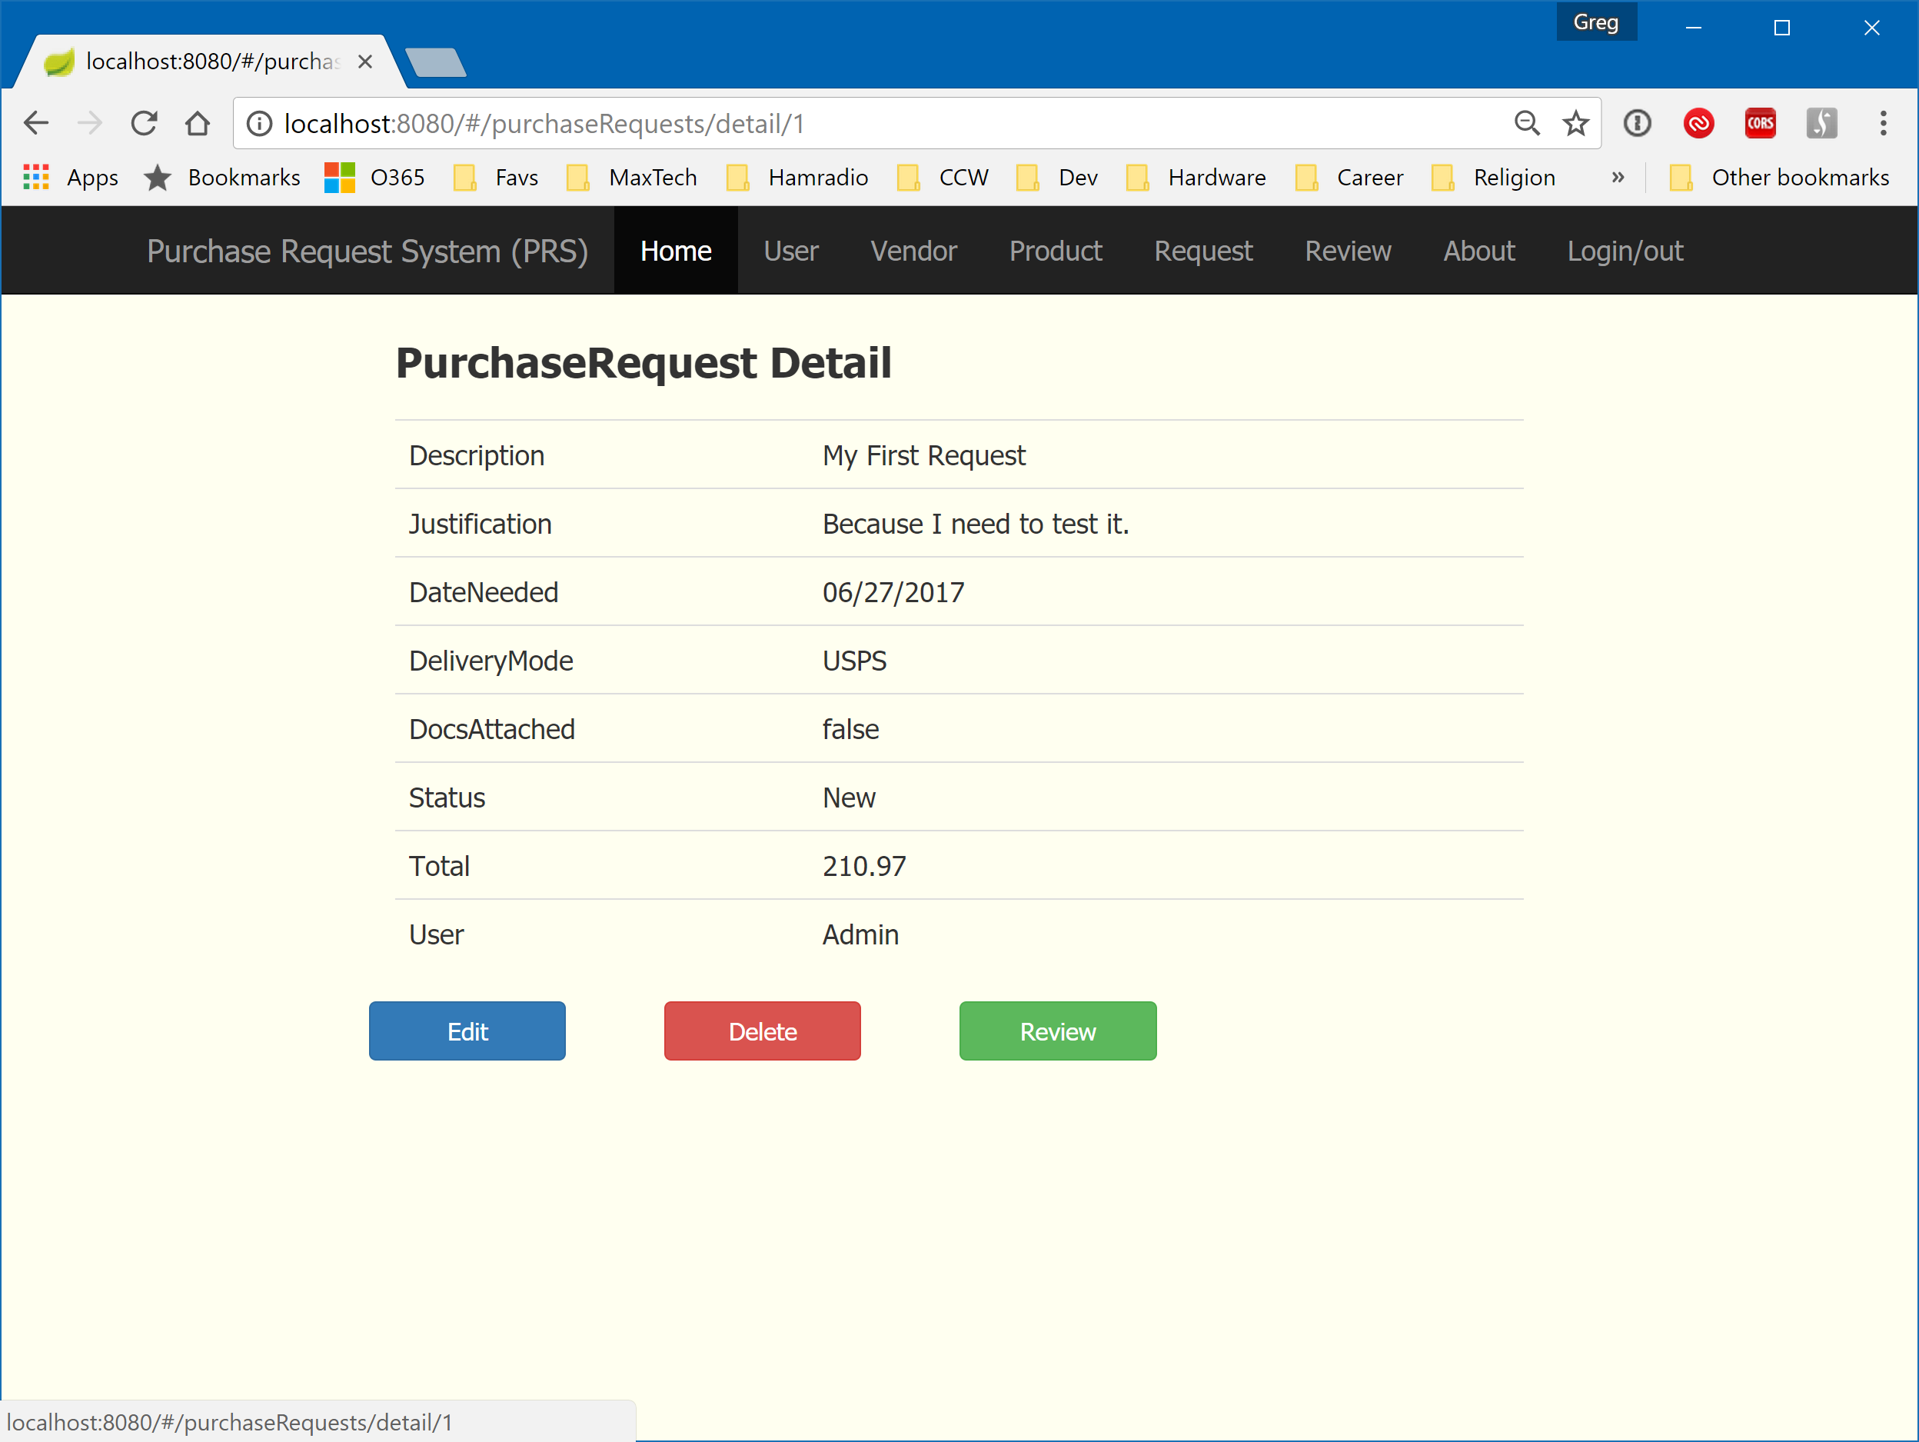

Figure - Purchase Request Detail (Admin View)

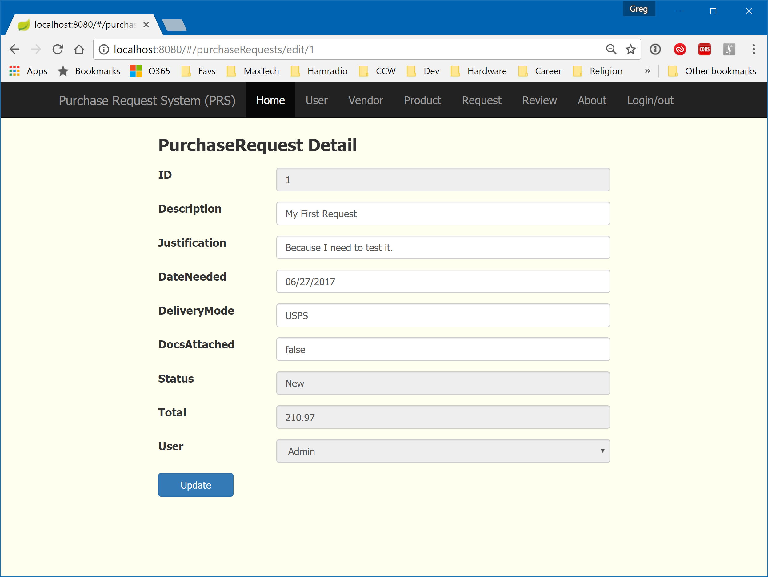

Figure - Purchase Request Edit (Admin View)

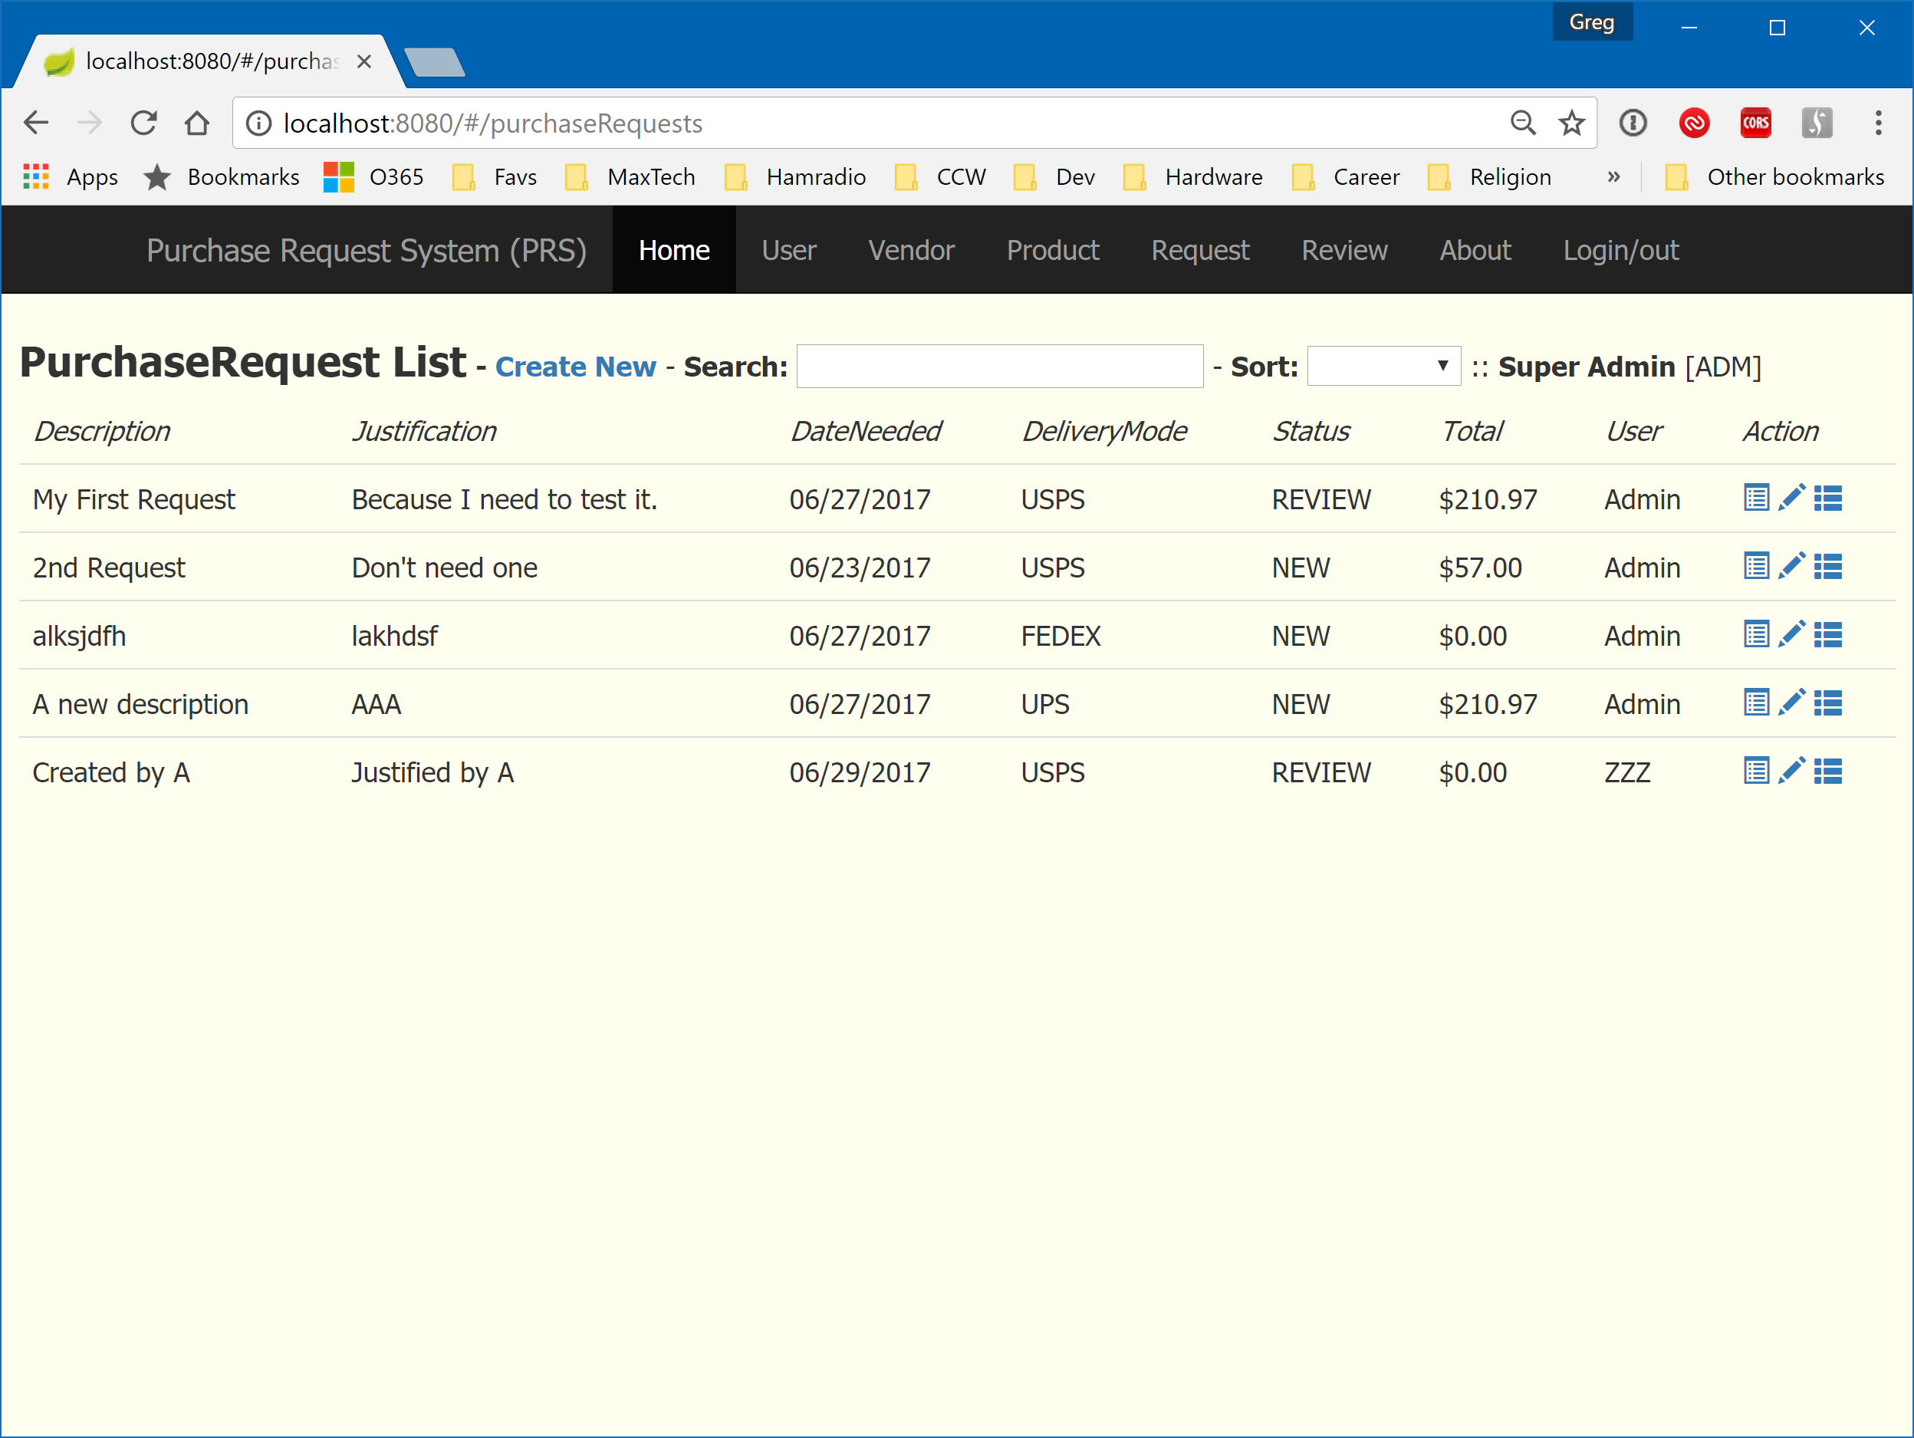

Figure - Purchase Request List with first item set to REVIEW

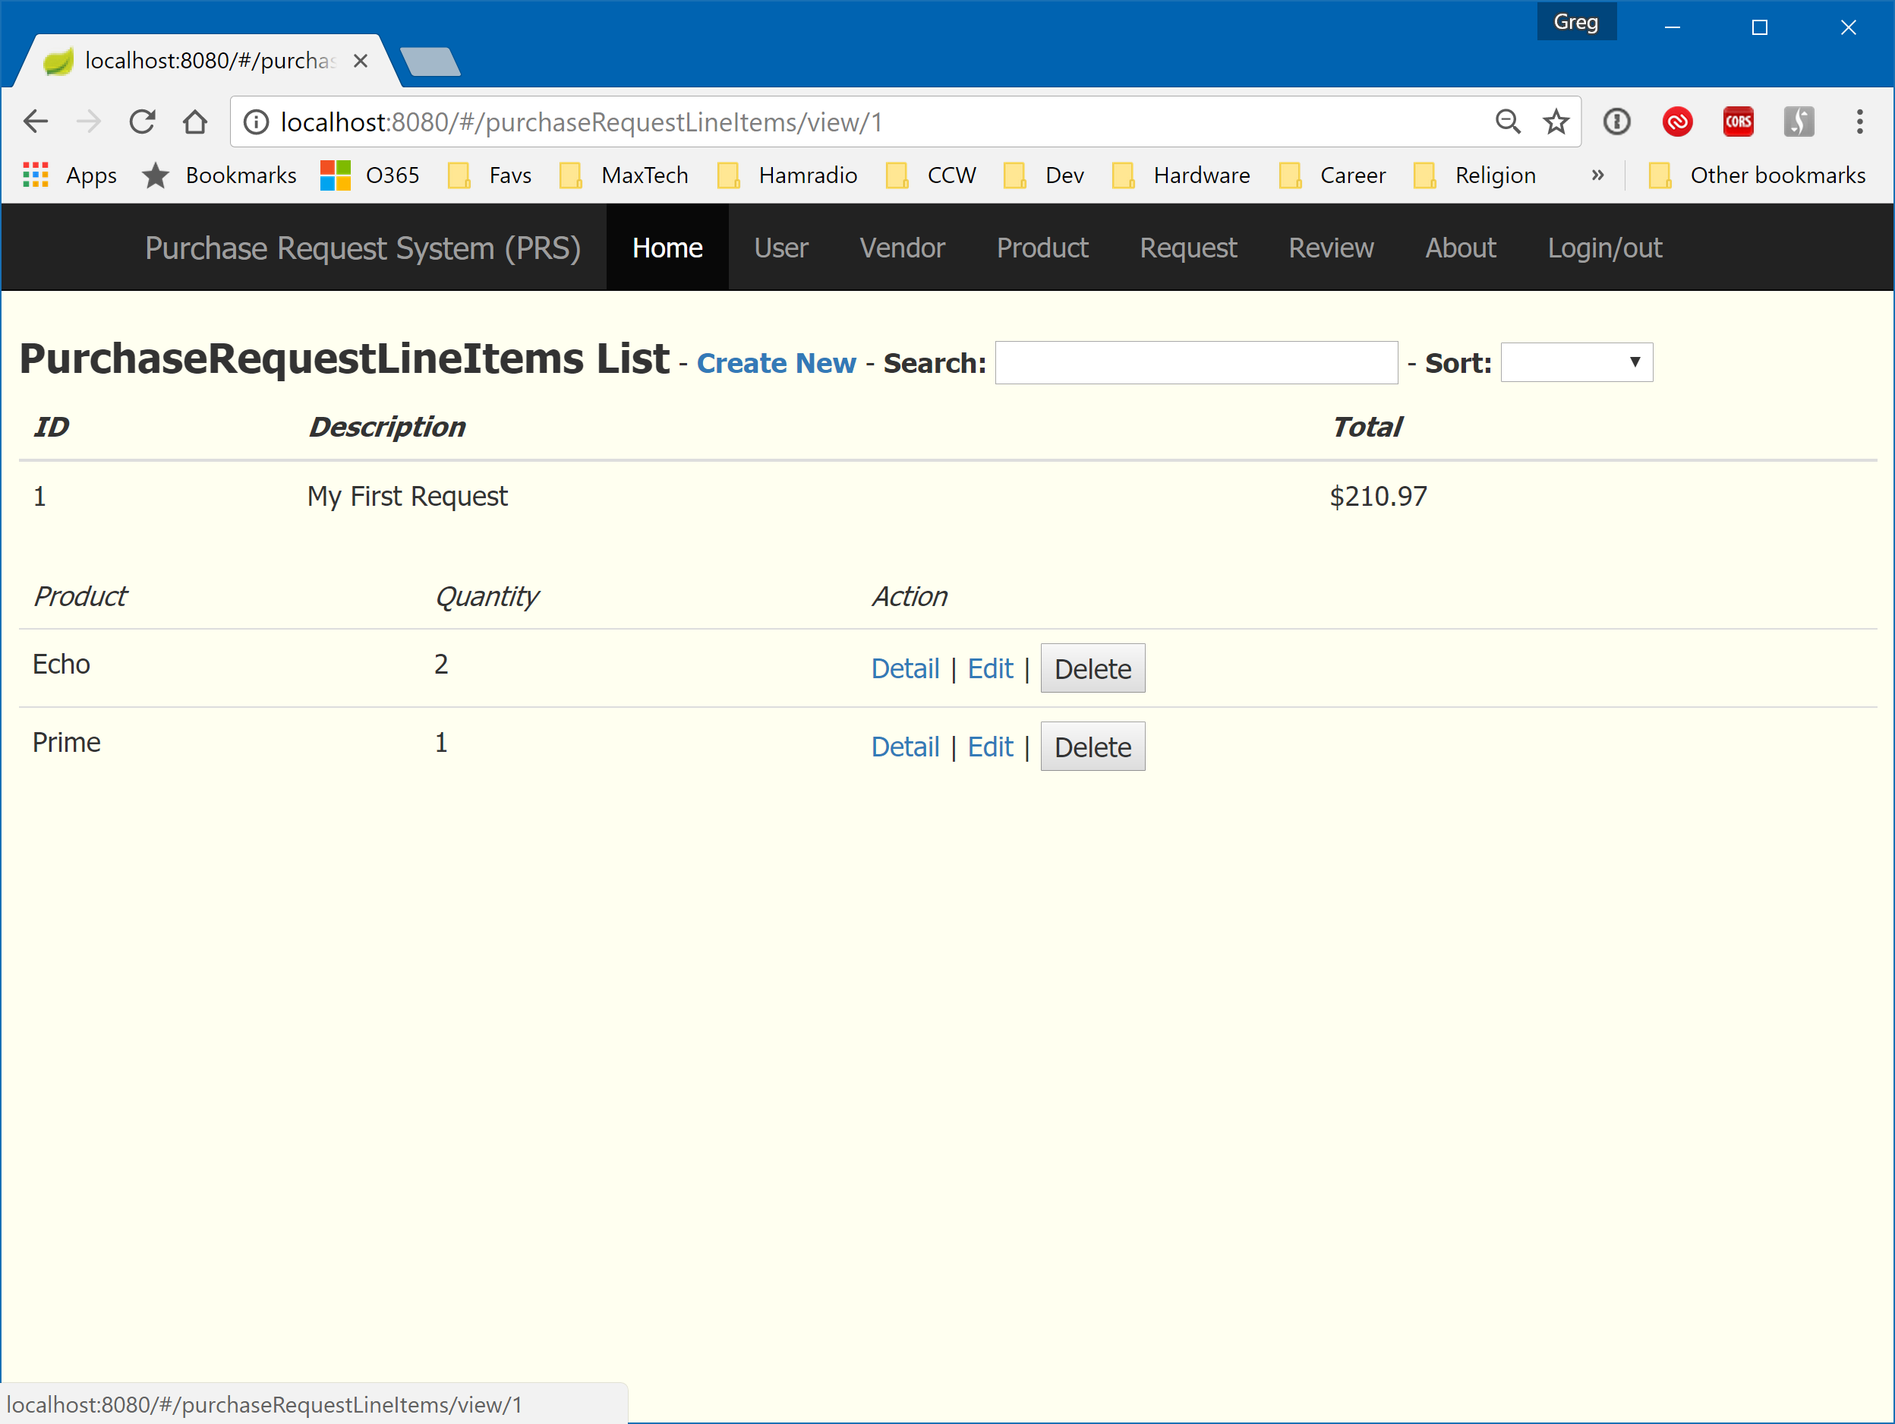

Figure - Purchase Request Detail (Admin View)

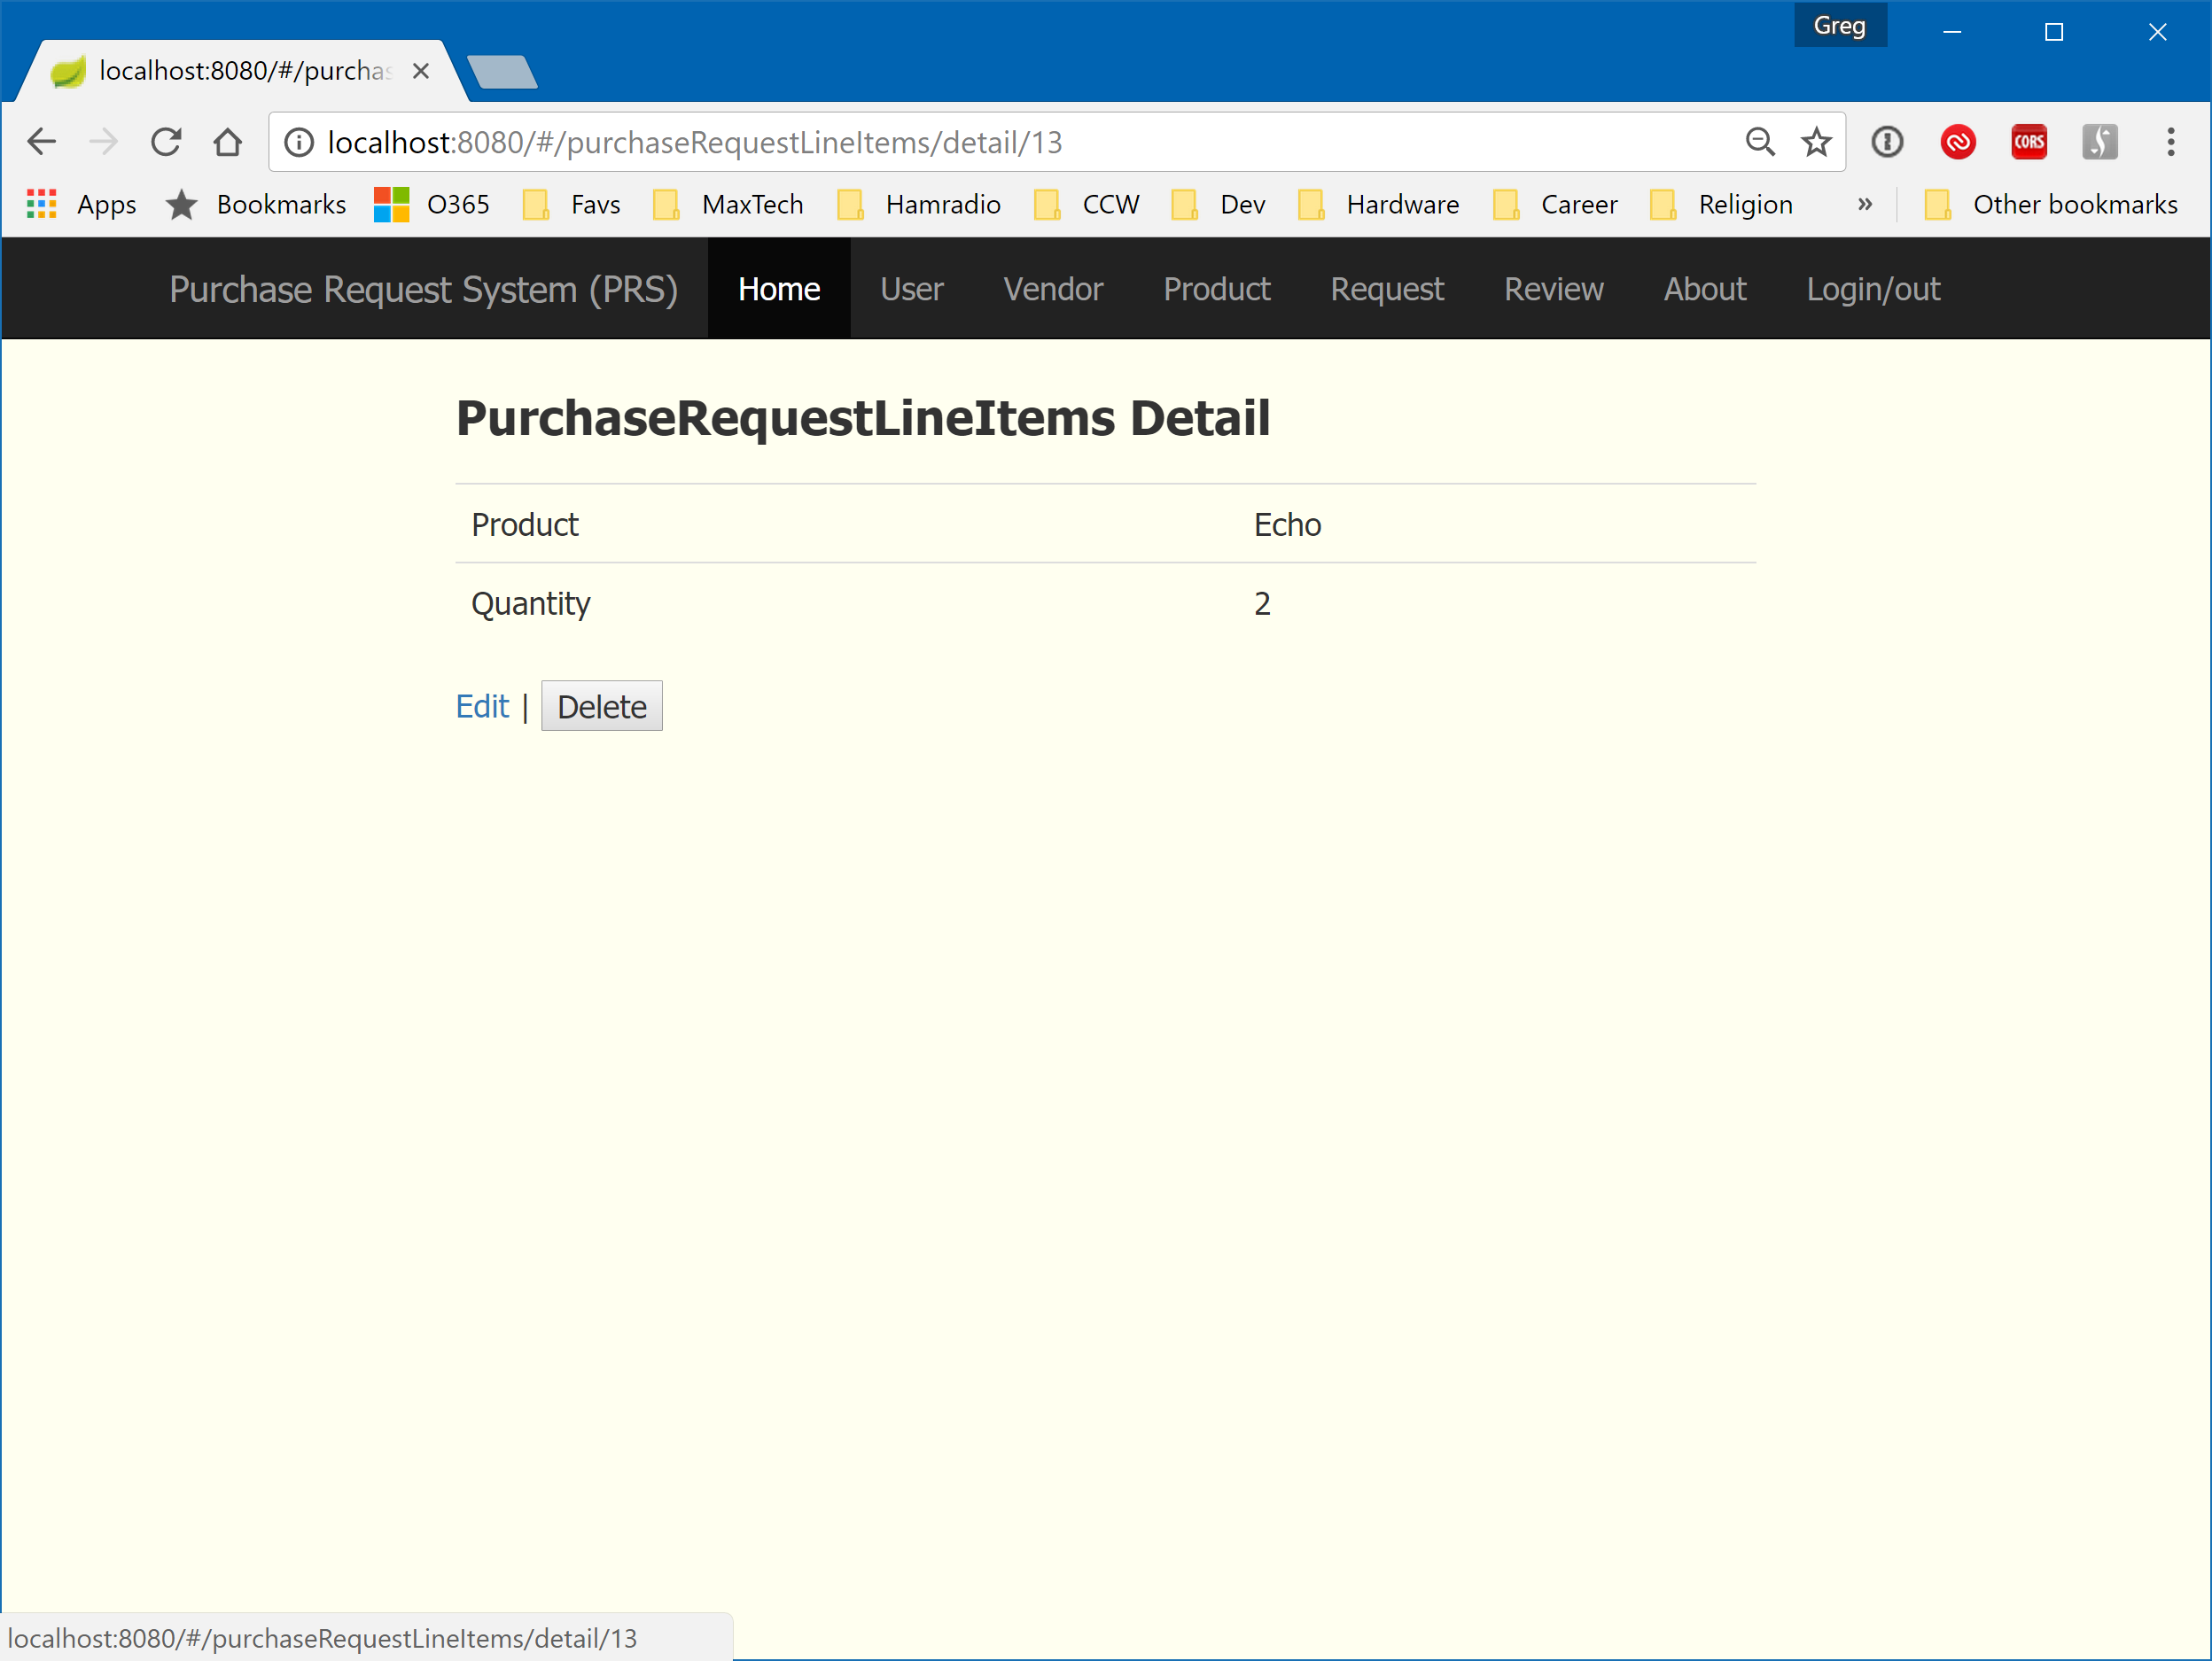

Figure - Purchase Request Line Item Detail (Admin View)

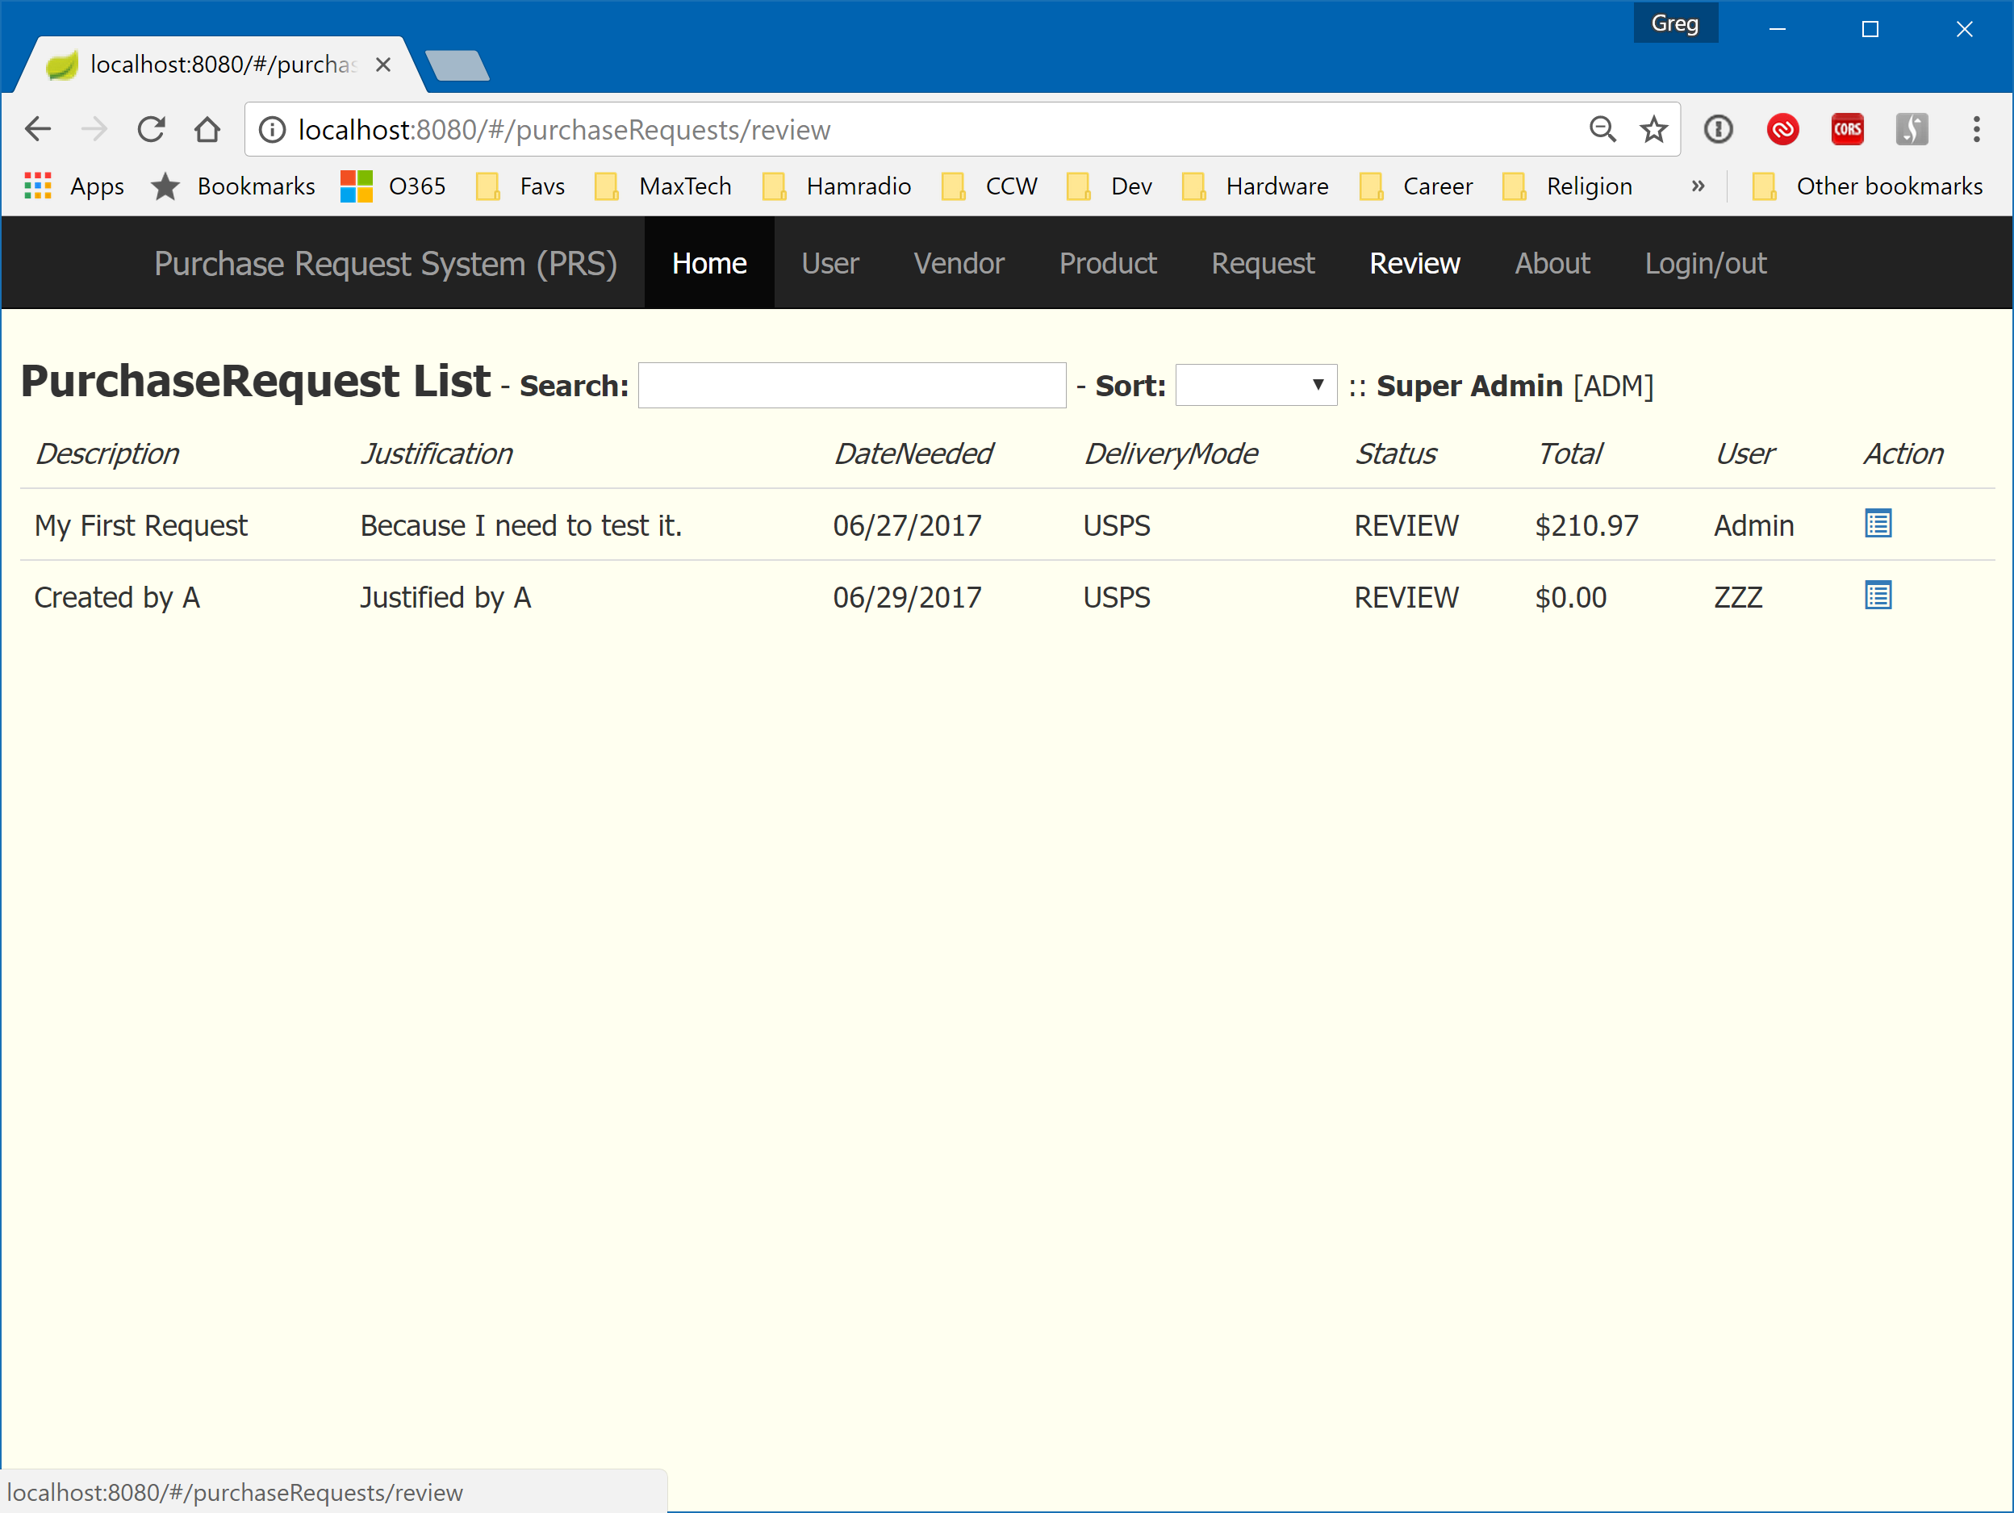

Figure - Purchase Request Review

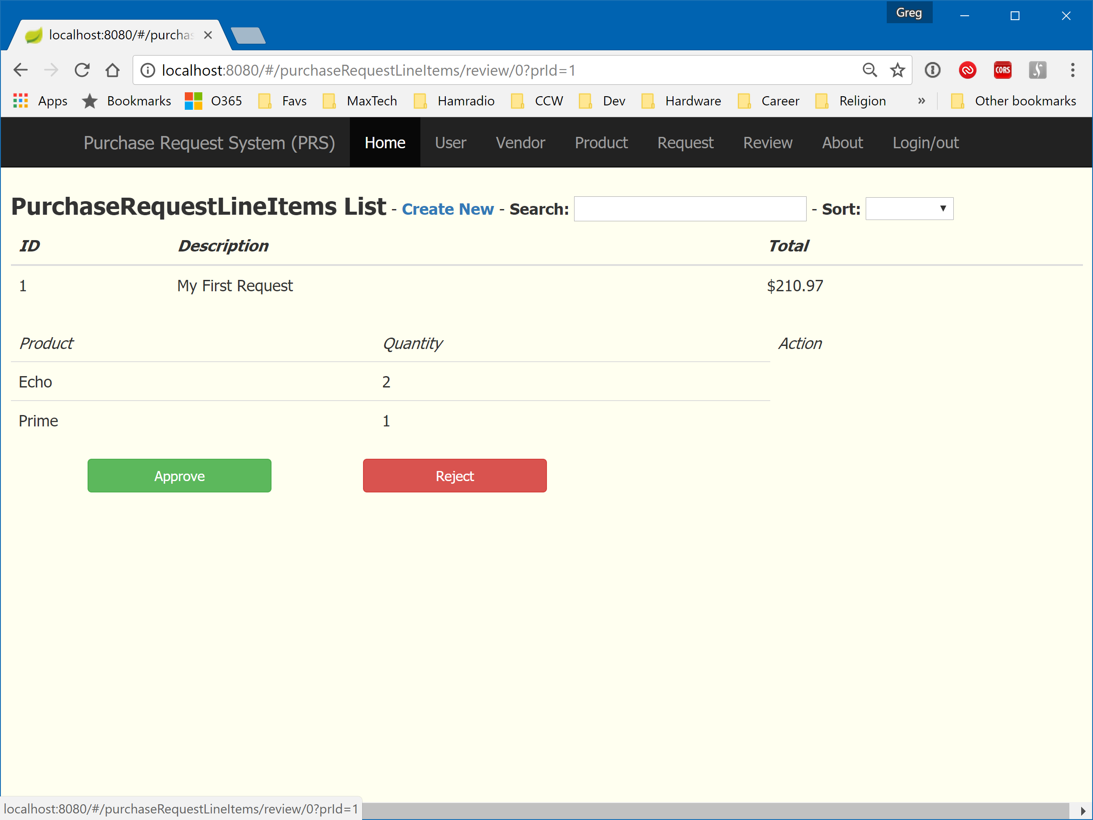

Figure - Purchase Request Review Detail

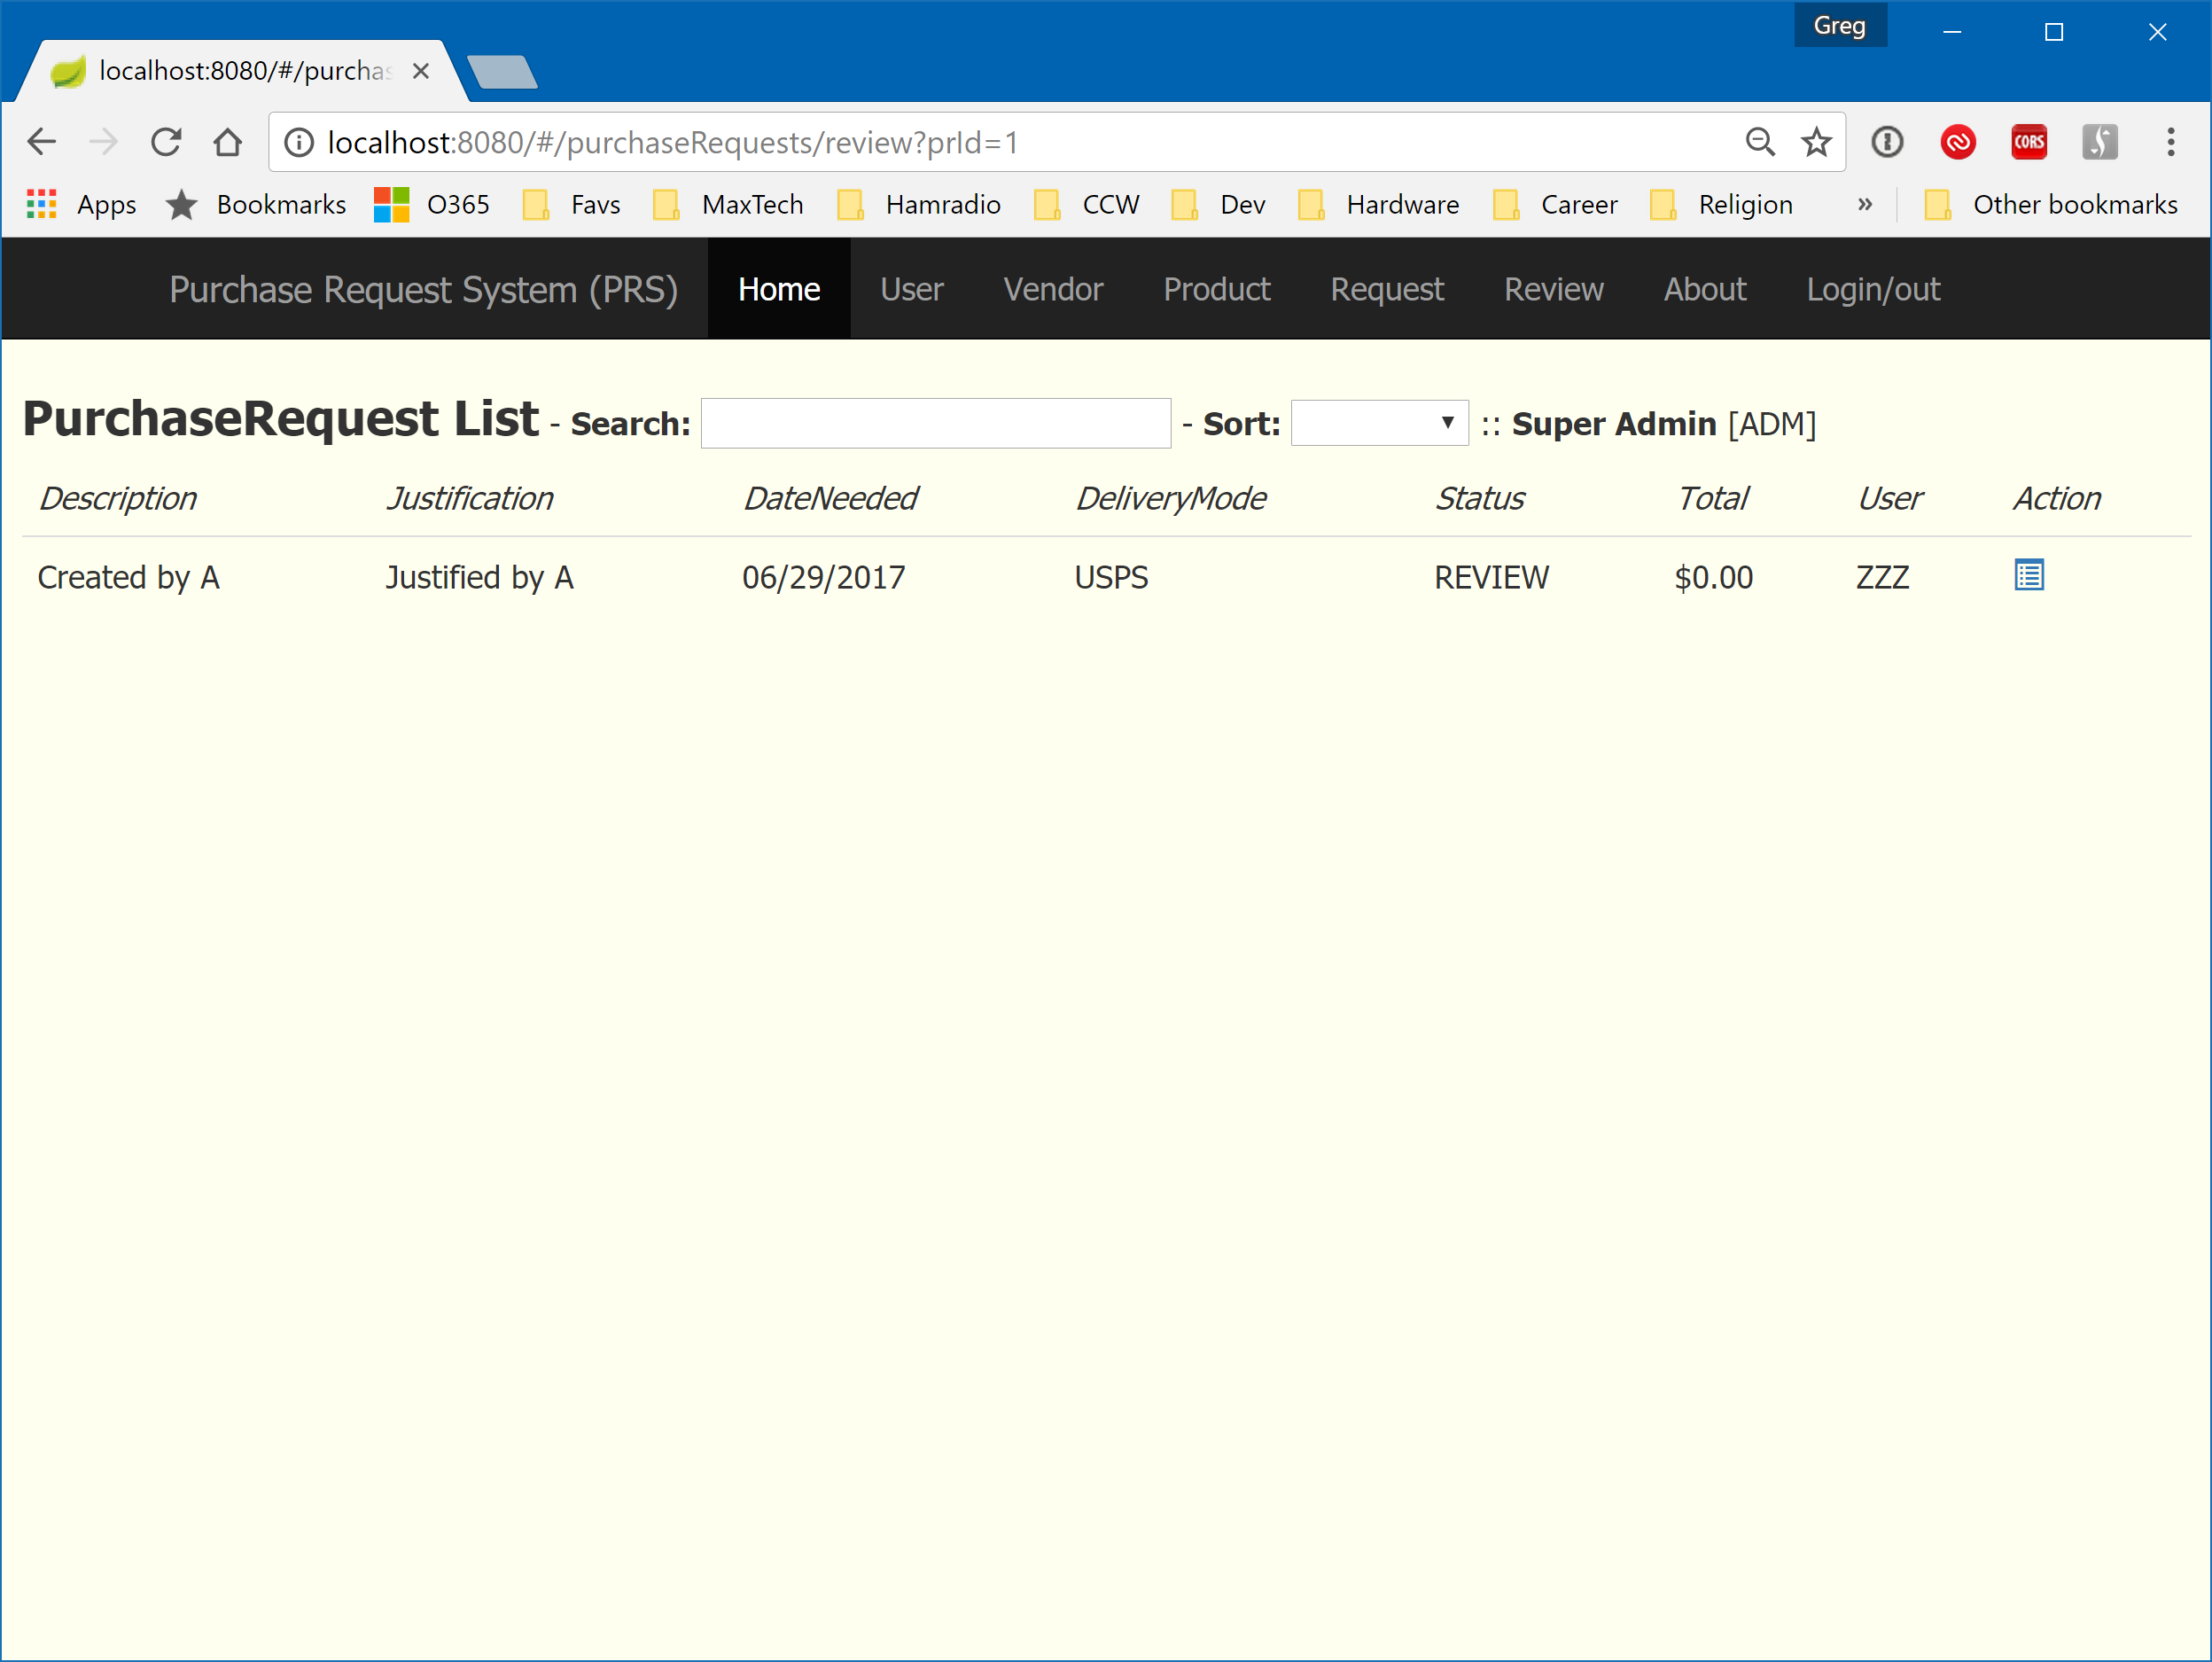

Figure - Purchase Request Review List (after rejecting an item)

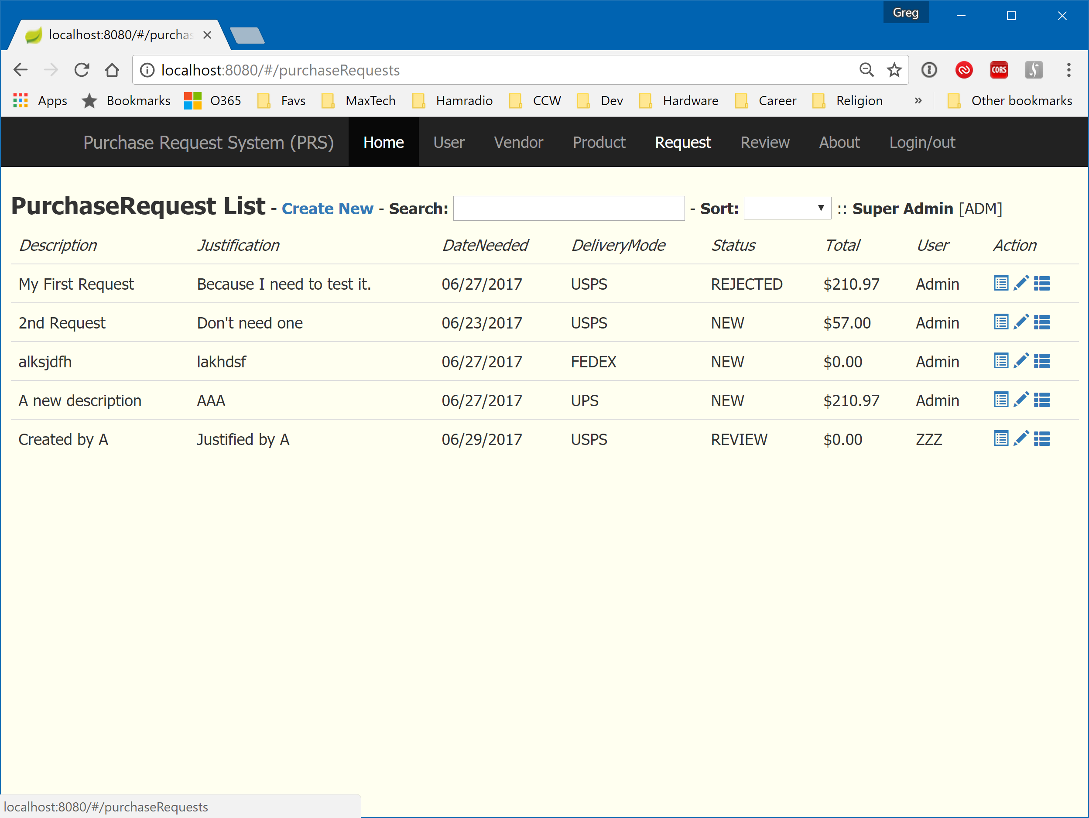

Figure - Purchase request Review List showing rejected purchase request

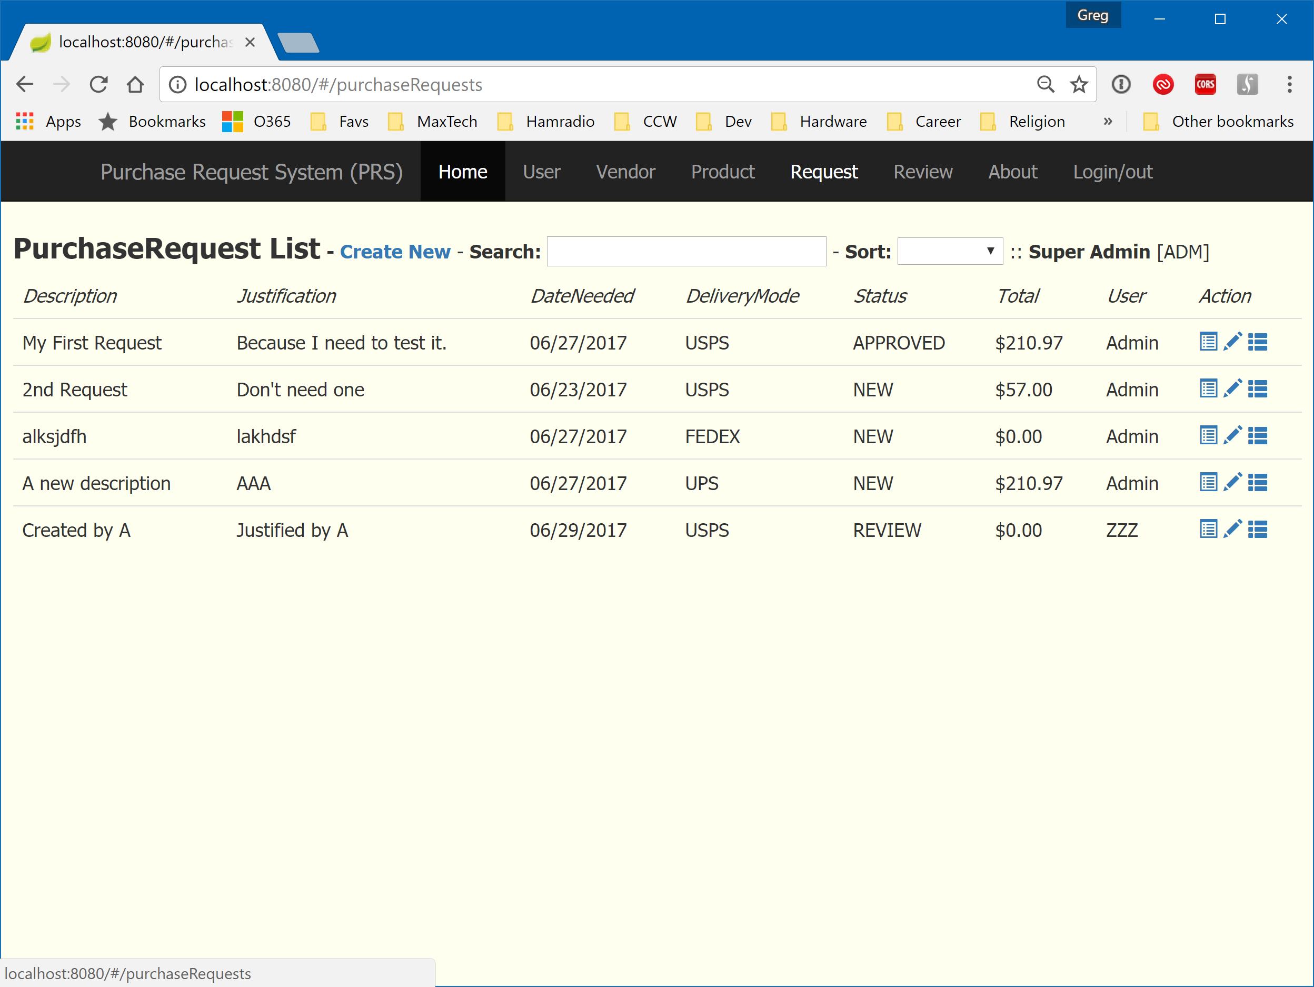

Figure - Purchase Request Review showing approved item

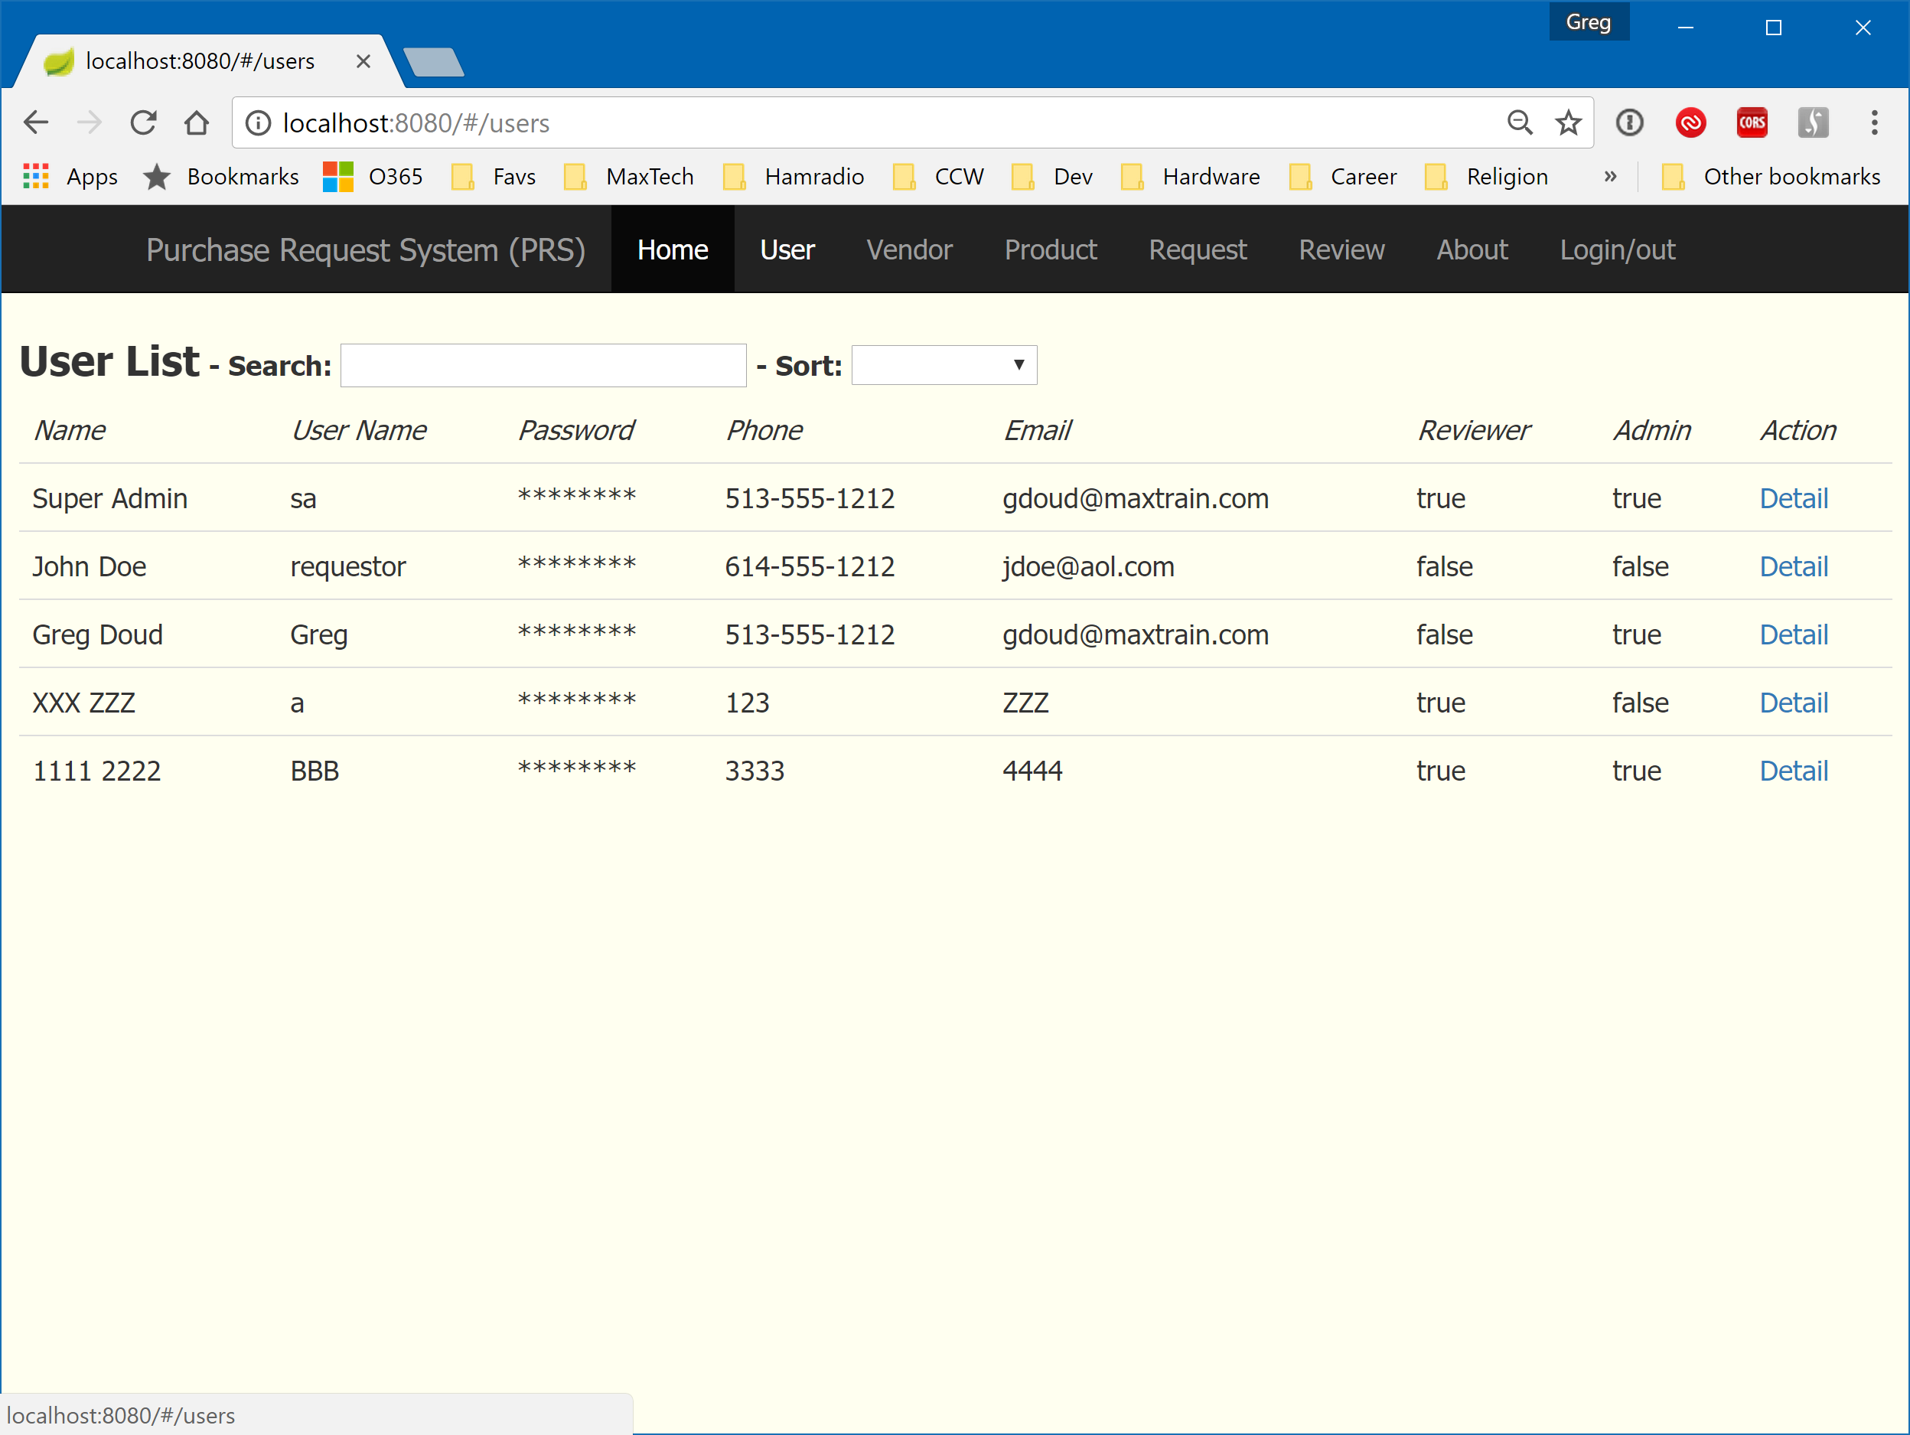

Figure - User List (Non-Admin View)

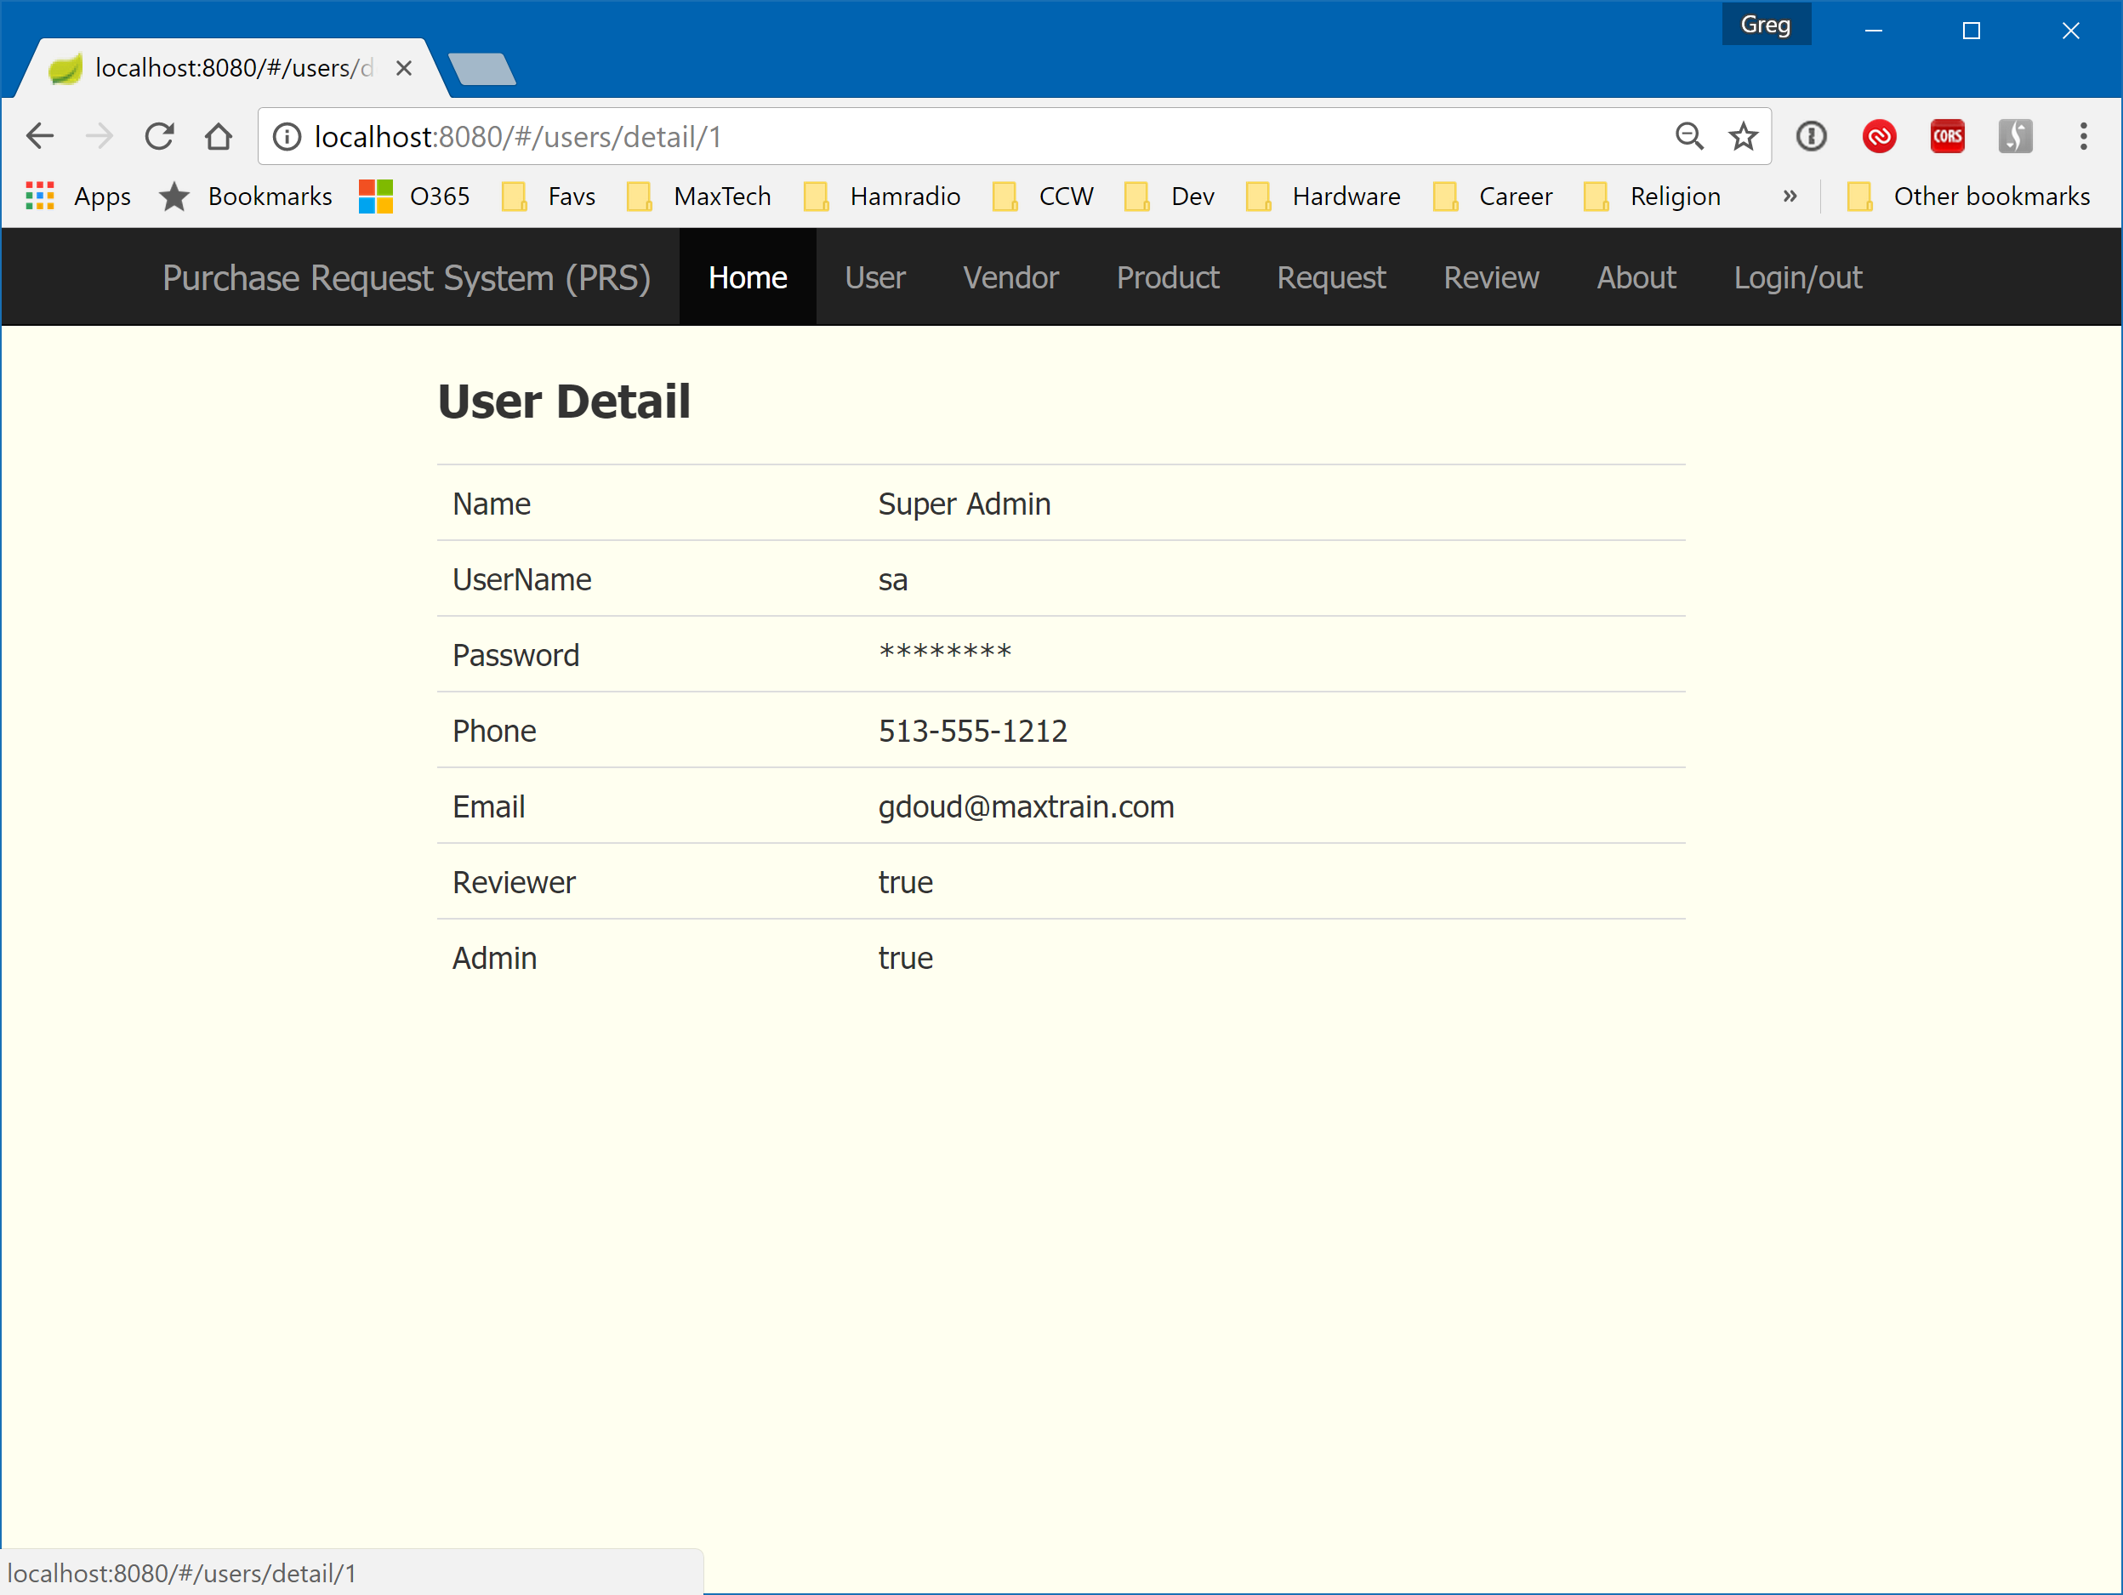

Figure - User Detail (Non-Admin View)